

Open Rack V3 IT Gear Input Connector

Rev: 1.6

Author:

Brian Costello TE Connectivity

License OCP CLA Option

Contributions to this Specification are made under the terms and conditions set forth in Open Compute Project Contribution License Agreement (“OCP CLA”) (“Contribution License”) by:

**TE Connectivity Solutions GmbH**

You can review the signed copies of the applicable Contributor License(s) for this Specification on the OCP website at <http://www.opencompute.org/products/specsanddesign>

Usage of this Specification is governed by the terms and conditions set forth in Open Web Foundation Final Specification Agreement (“OWFa 1.0”).

You can review the applicable Specification License(s) executed by the above referenced contributors to this Specification on the OCP website at http://www.opencompute.org/participate/legal-documents/

**Note**: The following clarifications, which distinguish technology licensed in the Contribution License and/or Specification License from those technologies merely referenced (but not licensed), were accepted by the Incubation Committee of the OCP:

Commercial Part Numbers listed in Section 9 are compliant part numbers for reference only.

NOTWITHSTANDING THE FOREGOING LICENSES, THIS SPECIFICATION IS PROVIDED BY OCP "AS IS" AND OCP EXPRESSLY DISCLAIMS ANY WARRANTIES (EXPRESS, IMPLIED, OR OTHERWISE), INCLUDING IMPLIED WARRANTIES OF MERCHANTABILITY, NON-INFRINGEMENT, FITNESS FOR A PARTICULAR PURPOSE, OR TITLE, RELATED TO THE SPECIFICATION. NOTICE IS HEREBY GIVEN, THAT OTHER RIGHTS NOT GRANTED AS SET FORTH ABOVE, INCLUDING WITHOUT LIMITATION, RIGHTS OF THIRD PARTIES WHO DID NOT EXECUTE THE ABOVE LICENSES, MAY BE IMPLICATED BY THE IMPLEMENTATION OF OR COMPLIANCE WITH THIS SPECIFICATION. OCP IS NOT RESPONSIBLE FOR IDENTIFYING RIGHTS FOR WHICH A LICENSE MAY BE REQUIRED IN ORDER TO IMPLEMENT THIS SPECIFICATION. THE ENTIRE RISK AS TO IMPLEMENTING OR OTHERWISE USING THE SPECIFICATION IS ASSUMED BY YOU. IN NO EVENT WILL OCP BE LIABLE TO YOU FOR ANY MONETARY DAMAGES WITH RESPECT TO ANY CLAIMS RELATED TO, OR ARISING OUT OF YOUR USE OF THIS SPECIFICATION, INCLUDING BUT NOT LIMITED TO ANY LIABILITY FOR LOST PROFITS OR ANY CONSEQUENTIAL, INCIDENTAL, INDIRECT, SPECIAL OR PUNITIVE DAMAGES OF ANY CHARACTER FROM ANY CAUSES OF ACTION OF ANY KIND WITH RESPECT TO THIS SPECIFICATION, WHETHER BASED ON BREACH OF CONTRACT, TORT (INCLUDING NEGLIGENCE), OR OTHERWISE, AND EVEN IF OCP HAS BEEN ADVISED OF THE POSSIBILITY OF SUCH DAMAGE.

Table of Contents

1. Scope 4

2. Overview 4

3. Electrical 4

4. Mechanical 5

4.1 Geometry 5

4.2 Mating to the Busbar 5

4.3 Transport Requirements 5

4.4 Screw Mount Connector Detail 5

4.5 Toolless Mounted Connector Detail 7

4.6 48V Busbar 10

5. Environmental Requirements: 11

6. Test Busbar Mechanical Requirements 11

7. Quality 13

8. Regulatory 15

9. Commercial Part Numbers 15

10. Revisions 15

11. Acknowledgements 16

# Scope

This document defines the technical specifications for an Open Rack V3 IT Gear 48V Input Connector used in the Open Compute Project.

# Overview

This interconnection is the power interface between Open Rack V3 IT Gear equipment and the Open Rack V3 48V bus bar.

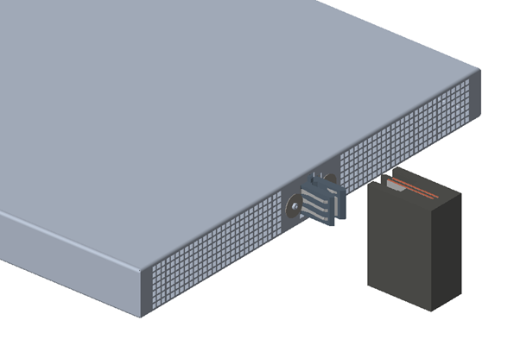

**Figure 1: IT Gear Chassis and ORv3 Busbar**

# Electrical

* Voltage range: 46.0V – 52.0V DC
* Power Contact Max current continuous: 100A DC
* Chassis Ground Contact Max Current for 2 min duration: 64A total
* Max temperature rise: 30°C (with busbar connected, as specified on ORv3 busbar Spec)
* Max voltage drop: 55mV @ 100A

# Mechanical

## 4.1 Geometry

* The connector shall fit within the maximum height of a 1 Rack Unit (44.45mm) including vertical connector float (as defined in section 4.2).
* The connector shall support a panel thickness of 0.90 to 1.32 mm.
* The connector MAY use tools to attach the connector to the IT Gear equipment or shelf.
* Torque range for applicable mounting hardware shall be 0.4-0.6 N-m.
* Power Wires shall resist pullout from the connector of 15kgf.

## 4.2 Mating to the Busbar

* The connector shall support blind-mate installation of the IT Gear onto the 48V busbar (figure 7) as defined in the Open Compute Specification Revision 3.0.
* Connector power contacts to be plated with Silver over Nickel in busbar mating zone
* Connector shall support ±3mm float horizontally and ±2mm vertically
* Connector shall enable 6.4mm side to side gather ability
* Connector chassis ground contacts shall provide a connection to the busbar cage and carry 64A current for a maximum duration of 2 minutes which is 2 times the rated max AC input current of 32A.
* Connector chassis ground contact to be plated with matte tin over nickel in the busbar ground mating zone.
* Connector to have a sense contact on each side of the connector that mates 1mm after the 48V power contact mates.
* Sense contact to carry up to 1.5A current with a temperature rise of no more than 30°C
* Sense contacts to be plated with Silver over Nickel in busbar mating zone
* Connector shall support 3.5mm of wipe for the sense contact at worst case chassis tolerance.
* The max rate of the IT Gear insertion into the rack will be 1 m/s.
* The mating force of the connector onto the busbar shall be less than or equal to 100N.

## 4.3 Transport Requirements

The power shelf will ship within the rack while connected to the rack busbar. The connector solution shall prevent damage of the power shelf and the rack busbar during the following packaged, rack-level tests (ASTM 4169 details below) while meeting the voltage drop requirements per section 6.0 and show no exposed copper of either the power shelf connector or rack busbar under SEM analysis of the interfaces.

The rack is tested in the shipping packaging for transportation Shock and Vibration per ASTM 4169-16 Schedule E - Vehicle Vibration for 2hrs on vertical axis only for 80 minutes low level, 30 minutes medium level and 10 minutes high level.

## 4.4 Screw Mount Connector Detail

The screw mounted connector is mounted to the IT Gear rear panel from the inside of the IT Gear equipment. It is fastened to the panel using (2) M3 screws (6.0mm MAX head diameter and 2.5mm MAX head height) and (2) 20mm diameter washers, 1.0 +0.5/-0.0mm Thick. The washers are applied from the outside of the IT Gear thus capturing the panel between the connector body on the inside and the washers on the outside.

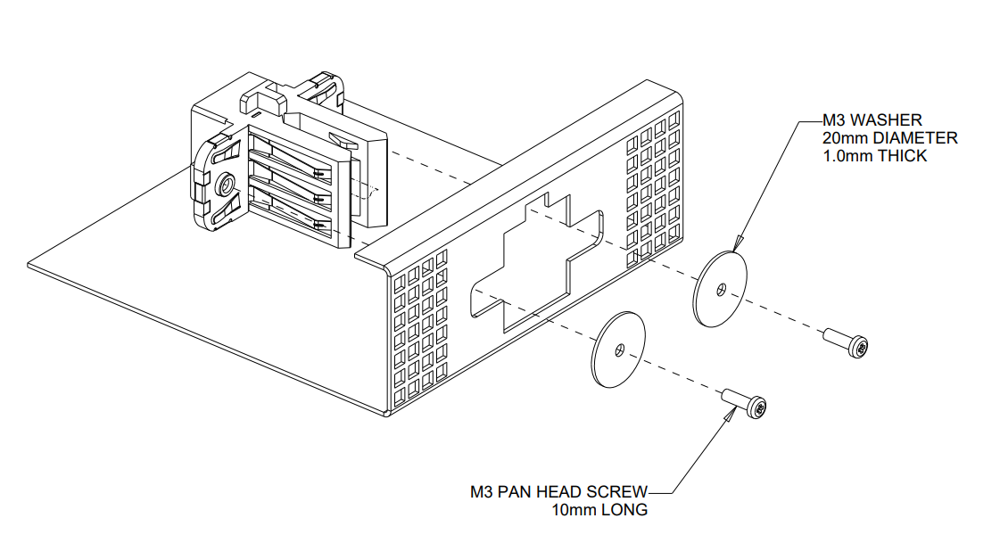

**Figure 2: IT Gear Connector Installation, Screw Mounted**

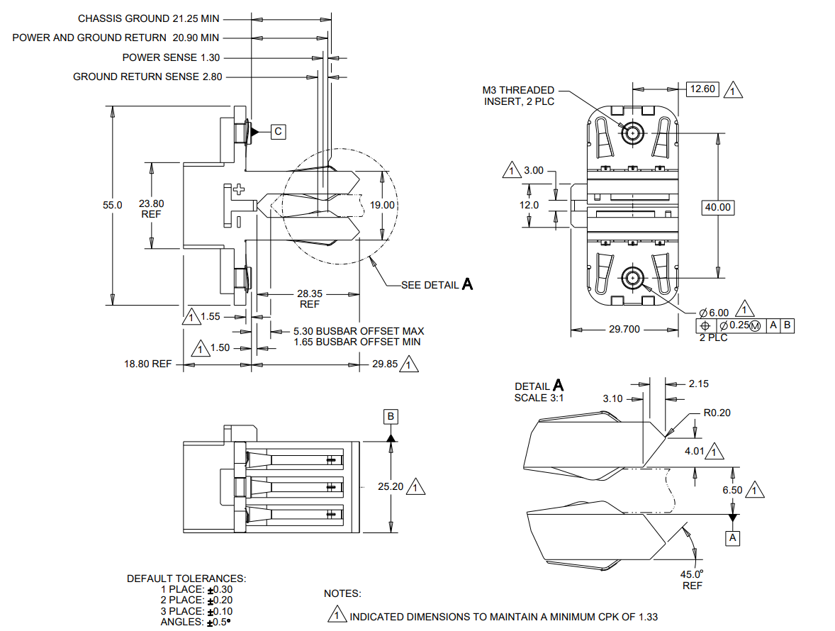

**Figure 3: IT Gear Connector Detail, Screw Mounted**

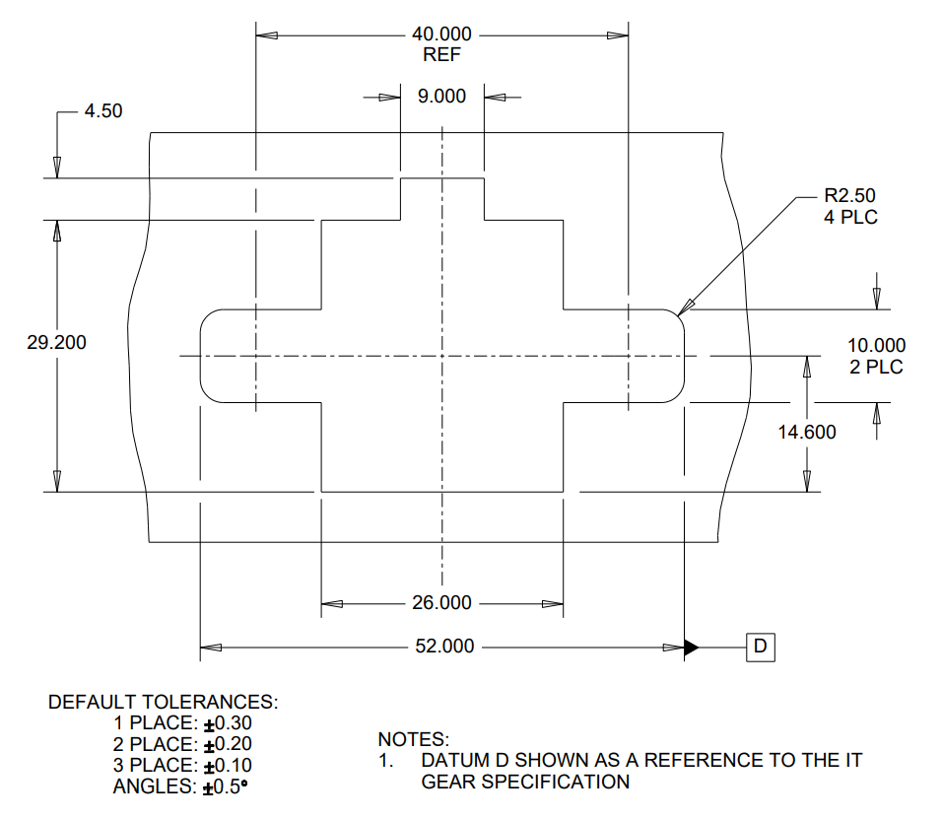

**Figure 4: Panel Cutout for Screw Mounted Connector**

## 4.5 Toolless Mounted Connector Detail

The toolless mounted connector is attached to the IT Gear rear panel from the inside of the IT Gear equipment. It is inserted through the panel on one side of the panel opening and moved to the center of the opening. Once in that position, the locking feature is to be engaged thus preventing the connector from being able to be moved back to the position in which it was inserted through the panel opening. To remove the connector from the panel, first dis-engage the locking tab then slide the connector to the side. Once the front tabs are aligned with the top and bottom openings, the connector can be removed from the panel.

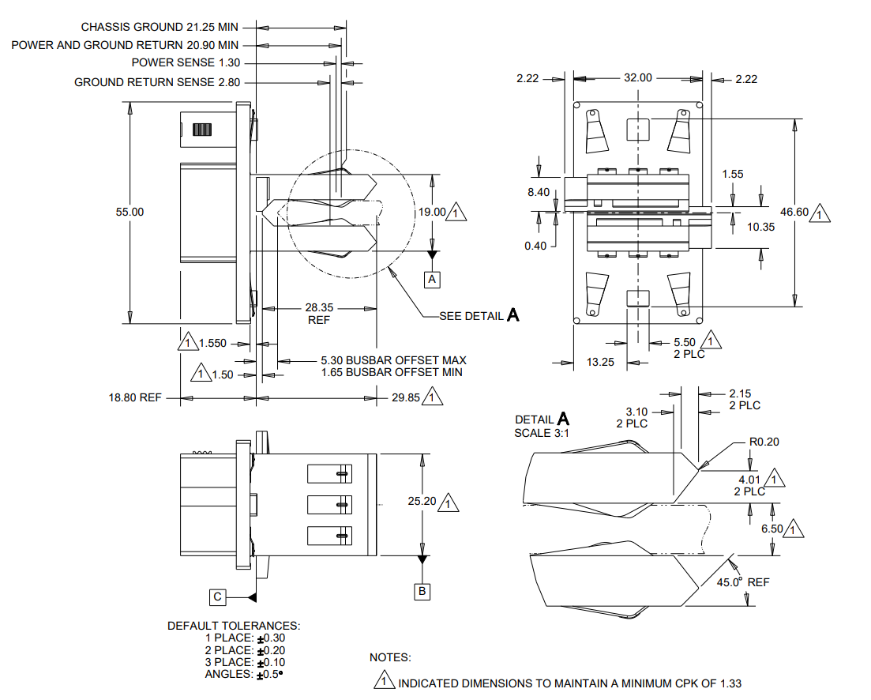

**Figure 5: IT Gear Connector Detail, Toolless Mounted**

The height of the top and bottom pass through openings in the panel cutout may need to be adjusted depended on the IT Gear equipment size and chassis design. For equipment designed for a 1 RU (44.45mm) spacing, the panel cutout may require that the opening height will have to extend around any sheetmetal bends. For equipment designed for a 1 OU (48.0mm) spacing, the panel cutout can be located completely in the flat section of the rear panel so no adjustment should be necessary.

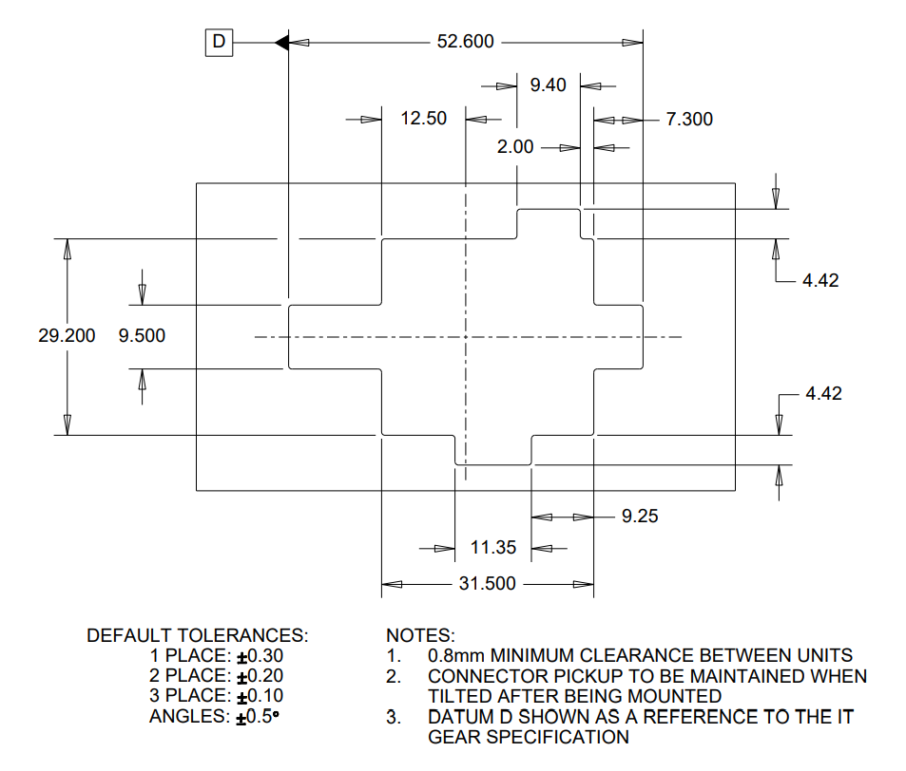

**Figure 6: Panel Cutout for Toolless Mounted Connector**

## 4.6 48V Busbar

The ORv3 48V Busbar is defined in the Open Rack Standard V3.0 specification. The busbar details shown below are provided for reference only.

**Figure 7: ORv3 Busbar Mechanical Detail**

# Environmental Requirements:

* Connector shall be rated for continuous current in still air (no airflow).
* Operating Ambient Temperature at connector location: 15°C to 70°C
* Long-term Storage: -40C to 50C and 5-95% RH
* Short-term Storage: -20C to 65C and 10-80% RH
* Operating Humidity: 20-90%, 5C dew point minimum
* Lifetime: 5 years

# Test Busbar Mechanical Requirements

* IT Gear test busbar to enable testing of the IT Gear connector
* Copper conductors (C1100 or equivalent) with silver over nickel plating in the connector mating zone (minimum)
* Steel cage with matte tin over nickel plating on the connector ground mating zone
* M6 threaded stud connections provided on the busbar and cage
* Contact Amphenol for pricing and availability. Amphenol part number 703110002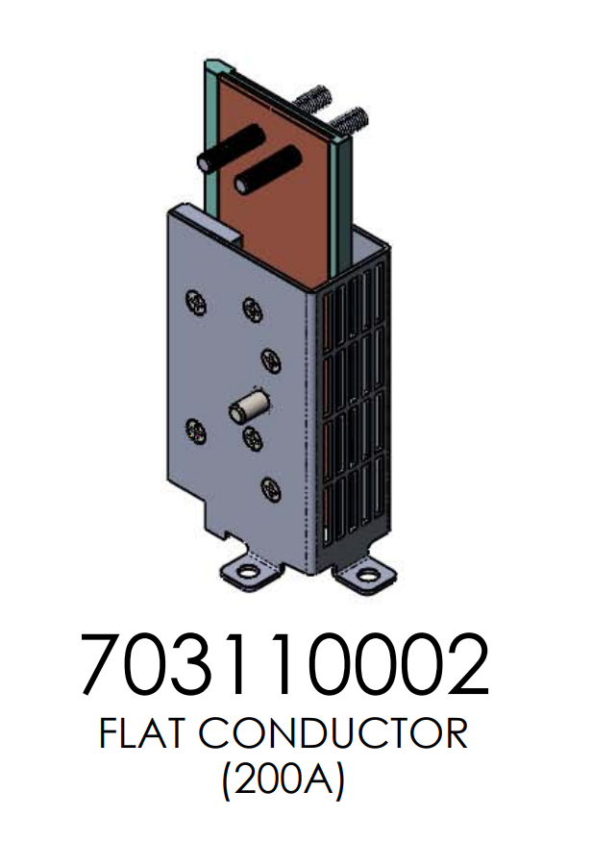

**Figure 8: ORv3 Test Busbar**

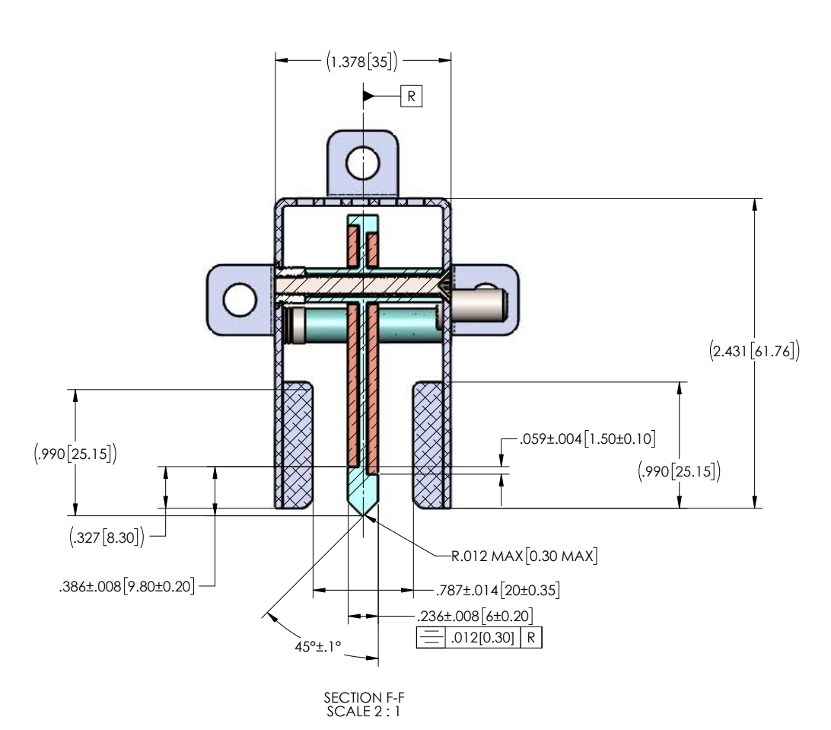

**Figure 9: ORv3 Test Busbar Cross Section Detail**

# Quality

The following tests will be conducted with three samples each per Table 1.

**Table 1: Testing Detail**

|  |  |  |  |  |
| --- | --- | --- | --- | --- |
| **Test** | **Test Standard** | **Test Condition/ Method** | **Pass/Fail Criteria** | **Additional Data to Collect for Review** |
| Low level contact resistance (LLCR) | EIA-364-23 | Subject mated specimens to 100 milliamperes maximum current and 20 millivolts maximum open circuit voltage. | 10 milliohms maximum (initial)  20 milliohms maximum (final) |  |
| Contact resistance at rated current (CRRC) | EIA-364-6 | Resistance should be measured after the clip has reached thermal equilibrium, after carrying Rated load at 25°C ambient temperature. | 0.55 milliohms maximum (initial and final) |  |
| Withstanding voltage | EIA-364-20, Condition I | 1000 volts AC at sea level for power contacts. 1 minute duration. Test between adjacent contacts of specimens. | No breakdown or flashover |  |
| Durability | EIA-364-09 | Mate and un-mate specimens with mating cable assembly for 50 cycles at a maximum rate of 500 cycles per hour. | LLCR before and after  Post test surface wear examination: no exposed nickel or copper |  |
| Contact Retention | EIA-364-29, Method A | 15kgf pull force, both axial and at 45degrees, for a minimum of 6 seconds | No visible contact to housing displacement | N/A |
| Wire Retention (Parallel to the wire direction) | UL486 | Pull force per wire gauge as defined in the specification | No visible contact to housing displacement | N/A |
| Wire Retention (perpendicular to the wire direction) | N/A | Half the pull force defined in UL486 will be applied perpendicular to the wire direction | No visible reduction in contact to contact distance | N/A |
| Vibration | EIA-364-28 Test condition VII, Test condition E | 15 minutes duration in each of the three mutually perpendicular direction | No discontinuities of 1 microsecond or longer duration.  No plastic deformation or contact dislodging. In addition: LLCR before and after | post test contact wear optical examination,  SEM/EDX optional |
| Shock | EIA-364-27, Method A | Subject mated specimens to 50G’s half-sine shock pulses of 11 milliseconds duration.  Three shocks in each direction applied along 3 mutually perpendicular planes, 18 total shocks. | No discontinuities of 1 microsecond or longer duration.  No plastic deformation or contact dislodging. | post test contact wear optical examination,  SEM/EDX optional |
| Mating Force | EIA-364-13 | Measure force necessary to mate specimens at a maximum rate of 12.7 mm [.5 in] per minute. | 100 N maximum per receptacle cable assembly |  |
| Un-mating force | EIA-364-13 | Measure force necessary to un-mate specimens at a maximum rate of 12.7 mm [.5 in] per minute. | 12 N minimum per receptacle cable assembly |  |
| Temperature Life | EIA-364-17, Method A, Condition 5. | Subject mated specimens to 125°C for 500 hours. | LLCR before and after | monitor contact voltage drop during test |
| Thermal Shock | EIA-364-32, Method A | Test condition VII: -55C to 85C for 10 cycles with 30 minute dwell time | LLCR before and after | N/A |
| Humidity | EIA-364-31, Class III | Subject mated specimens to 10 cycles (10days) between 25 and 65°C at 80 to 98% RH | LLCR before and after Dielectric withstand voltage before and after | N/A |
| Salt Spray | EIA-364-26C | Subject mated specimens to test for 48 hours, with a 5% solution salt spray, 35 +1/-2°C | LLCR before and after | N/A |
| Temperature rise vs. current (Power Contact)1 | EIA-364-70, Method II | Attach connector to test busbar according to section 6. Stabilize at a single current level until 3 readings at 5 minute intervals are within 1°C. | Lower than 30°C | N/A |

1. Multiple test samples may be connected in a single circuit (daisy chain) for t-rise testing. However, the current capability of jumper wires/cables connecting each test sample must be less than 125% of the target connector current. Example: the current capability of jumper wires/cables must not exceed 125A@30°C when connecting 100A@30°C test samples.

# Regulatory

The connector shall comply with the latest edition, revision, and amendment of the following Standards:

* IEC 62368-1, Audio/video, information and communication technology equipment – Part 1: Safety requirements (applicable to meet anticipated effective date of December 20, 2020 for North America and Europe.)
* Halogen Free per JEDEC JS709C
* RoHS 2011/65/EU (RoHS 2)
* Material flammability: All materials shall be UL94 V-0 rated.
* Connectors shall be UL1977 recognized.

# Commercial Part Numbers

|  |  |  |
| --- | --- | --- |
| **Vendor** | **Description** | **P/N** |
| **TE Connectivity** | ORv3 100A 48V BB Cable, No Sense Contacts | 2389779-1 |
| **TE Connectivity** | ORv3 100A 48V BB Cable, 48V Sense Contacts | 2389779-2 |
| **TE Connectivity** | ORv3 100A 48V BB Cable, Ground Sense Contacts | 2389779-3 |
| **TE Connectivity** | ORv3 100A 48V BB Cable, 48V & Ground Sense Contacts | 2389779-4 |
| **Amphenol** | BarKlip BK150 IO cable | 10162876-* |
| **Molex** | ORV3 100A IT Gear Cable, 48V & Ground Sense Contact | 218194-* |
|  |  |  |
|  |  |  |
|  |  |  |
|  |  |  |
|  |  |  |
|  |  |  |
|  |  |  |

# Revisions

|  |  |  |  |
| --- | --- | --- | --- |
| Rev | Date | Author | Changes |
| 1.00 | 01 Dec 2021 | Brian Costello | Initial Release |
| 1.10 | 22 Dec 2021 | Brian Costello | Updated Figures to include Cpk on selected dimensions |
| 1.20 | 24 Jan 2022 | Brian Costello | Updated Figures, changed sense contact current desc. |
| 1.30 | 8 Feb 2022 | Brian Costello | Changed Connector Contact Dimension Scheme |
| 1.40 | 25 Mar 2022 | Brian Costello | Changed Toolless connector size to 55mm wide |
| 1.50 | 4 April 2022 | Brian Costello | Changed Locking Tab Width to 5.50mm |
| 1.60 |  |  |  |

# Acknowledgements

The following individuals provided help and support in the development of this document:

Pat DiPaola, TE Connectivity

Orando Li, TE Connectivity

Steve Mills, Meta

Steve Pressel, Molex

Dmitriy Shapiro, Meta