

Open Rack V3 Power Shelf

Rev: 1.0

11/10//2022

Authors:

Hamid Keyhani

Dmitriy Shapiro

John Fernandes

Ben Kim

Tiffany Jin

Rommel Mercado

License (OCP CLA Option)

Contributions to this Specification are made under the terms and conditions set forth in **Open Compute Project Contribution License Agreement (“OCP CLA”) (“**Contribution License”) by:

**META Platforms**

You can review the signed copies of the applicable Contributor License(s) for this Specification on the OCP website at <http://www.opencompute.org/products/specsanddesign>

Usage of this Specification is governed by the terms and conditions set forth in **Open Web Foundation Final Specification Agreement (“OWFa 1.0.)**

You can review the applicable Specification License(s) executed by the above referenced contributors to this Specification on the OCP website at http://www.opencompute.org/participate/legal-documents/

**Note**: The following clarifications, which distinguish technology licensed in the Contribution License and/or Specification License from those technologies merely referenced (but not licensed), were accepted by the Incubation Committee of the OCP:

None

NOTWITHSTANDING THE FOREGOING LICENSES, THIS SPECIFICATION IS PROVIDED BY OCP "AS IS" AND OCP EXPRESSLY DISCLAIMS ANY WARRANTIES (EXPRESS, IMPLIED, OR OTHERWISE), INCLUDING IMPLIED WARRANTIES OF MERCHANTABILITY, NON-INFRINGEMENT, FITNESS FOR A PARTICULAR PURPOSE, OR TITLE, RELATED TO THE SPECIFICATION. NOTICE IS HEREBY GIVEN, THAT OTHER RIGHTS NOT GRANTED AS SET FORTH ABOVE, INCLUDING WITHOUT LIMITATION, RIGHTS OF THIRD PARTIES WHO DID NOT EXECUTE THE ABOVE LICENSES, MAY BE IMPLICATED BY THE IMPLEMENTATION OF OR COMPLIANCE WITH THIS SPECIFICATION. OCP IS NOT RESPONSIBLE FOR IDENTIFYING RIGHTS FOR WHICH A LICENSE MAY BE REQUIRED IN ORDER TO IMPLEMENT THIS SPECIFICATION. THE ENTIRE RISK AS TO IMPLEMENTING OR OTHERWISE USING THE SPECIFICATION IS ASSUMED BY YOU. IN NO EVENT WILL OCP BE LIABLE TO YOU FOR ANY MONETARY DAMAGES WITH RESPECT TO ANY CLAIMS RELATED TO, OR ARISING OUT OF YOUR USE OF THIS SPECIFICATION, INCLUDING BUT NOT LIMITED TO ANY LIABILITY FOR LOST PROFITS OR ANY CONSEQUENTIAL, INCIDENTAL, INDIRECT, SPECIAL OR PUNITIVE DAMAGES OF ANY CHARACTER FROM ANY CAUSES OF ACTION OF ANY KIND WITH RESPECT TO THIS SPECIFICATION, WHETHER BASED ON BREACH OF CONTRACT, TORT (INCLUDING NEGLIGENCE), OR OTHERWISE, AND EVEN IF OCP HAS BEEN ADVISED OF THE POSSIBILITY OF SUCH DAMAGE.

# Table of Contents

Table of Contents 3

Revision History 5

1. Scope 6

2. Overview 6

3. Power shelf options 6

3.1. Power shelf option 1 – 6x 3kW PSU with dual cord (2x 20A NEC breaker upstream) 6

3.2. Power Shelf Option 2 – 6x 3kW PSU with Single Cord (32A IEC breaker upstream) 7

4. Electrical requirements 8

4.1. AC Electrical requirements 8

4.1.1. Facility Protection 8

4.2. DC Electrical requirements 9

4.3. Rectifier physical addressing 9

4.4. Monitoring & Control Interface 9

5. Mechanical Requirements 10

5.1. Power Shelf Assembly Dimensions 10

5.2. ORV3 Rack Mounting Feature 11

5.2.1. Front Latch & Bumper 11

5.2.2. Rear Stop 12

5.3. Connectors 13

5.3.1. AC Input connector 13

5.3.2. DC Output connector 15

5.3.3. Power Supply Connector 16

5.3.4. PMI connector 17

5.4. Front Access 18

5.5. Construction 18

5.6. Materials and Fasteners 19

5.7. Labeling & Markings 19

5.8. PSU Slot Blank 19

5.9. Mechanical Drawings 20

6. Thermal Requirements 22

6.1. Operational 22

6.2. Thermal design requirements 22

7. Environment/test requirements 23

7.1. Vibration and Shock (non-packaged) 23

7.2. Package Vibration, Drop and Compression 24

8. Reliability and Quality 25

8.1. Derating Design 25

8.2. Reliability Prediction 25

8.3. Design Failure Mode and Effect Analysis (DFMEA) 25

8.4. Reliability Tests 25

8.5. Sheet Metal Material and Zinc Whisker Implications 25

8.6. Manufacturing Quality and Production Tests 25

8.6.1 Hipot and Ground Continuity Test 26

8.6.2 DFT and DFM 26

8.6.3 Quality Control Process 26

8.6.4 Mass Production First Article Samples 26

8.7 Spec Compliance, Quality FA, Warranty 26

8.8 Mix-source Builds 27

8.9 Conformal Coating 27

8.10 Insulator 27

9. Compliance requirements 27

9.1. Safety Standards 28

9.1.1. Component Safety requirements 28

9.2. EMC Requirements 28

9.3. Environmental Compliance 29

9.4. Documentation 29

# Revision History

|  |  |  |  |
| --- | --- | --- | --- |
| Date | Version | Change By | Comments |
| 09/22/2020 | 0.5 | hamidk@  tjin@ | Updated spec to include FB requirements  ME update. |
| 09/28/2020 | 0.65 | hamidk@ | Updated section 4.1.1 |
| 10/09/2020 | 0.7 | hamidk@ | Removed requirement for grounding 48V return (negative) to the power shelf frame on sec 4.2 |
| 02/08/2021 | 0.71 | hamidk@ | Updated sec 7.1 and 7.2 to clean up shock/vib req. |
| 03/09/2021 | 0.72 | benkim@ | Updated Section 8 to add FB requirements |
| 07/23/2021 | 0.73 | dmshapir@  jfern@  rvmerc@ | Section 2: Added newer rendering  Section 5.1: Updated to new dimensions, new pictures  Section 5.2: Updates with new views  Section 5.3.1: Added new rear view and updated wiring configuration  Section 5.3.2: Updated to new connector design  Section 5.3.3: Updated to latest drawing view  Section 5.3.4: Included 2nd/3rd source, added latest drawing  Section 5.5-5.7: Updated with more thorough information  Sections 5.8-5.9: Newly added sections  Section 6: Updated numbers for back-pressure and exhaust temperature from upstream components  Section 7.1: Added required of PMI being inside shelf during test and testing to be done on soft & hard tooled parts  Added Section 8 |
| 8/18/2021 | 0.8 | hamidk@ | Removed FRU.  Added PMI diagram. |
| 01/06/2022 | 0.81 | dmshapir@ | Section 5.2.1: Added requirements around testing and material  Section 5.3.1: Updated guidance on connector usage and new star wire configuration diagram  Section 5.3.2: Updated details regarding new connector  Section 5.6: Updated clarification about materials  Section 5.8: Updated drawing  Section 5.9: Updated drawings  Section 8:5: Updated to Z18 minimum plating |
| 2/25/2022 | 0.82 | hamidk@ | Updated Short circuit current available to 25kA  Updated to use 0.1uF capacitor for ripple/noise measurements. |
| 08/24/2022 | 1.0 | Ted Tang | Updated to comply OCP 2022 specification template |

# Scope

This document defines the technical specifications for Open Rack V3 Power Shelves used in the Open Compute Project.

# Overview

The Open Rack Power Architecture is comprised of centralized scalable power shelf that distributes power over a common bus bar to the payload devices (IT Gear). This spec will define the power shelves that fits into the Open Rack. The power shelves shall house several rectifiers with minimum of N+1 redundancy to provide the dc power to all the payload inside the rack. Single shelf or multi-power shelves shall be used in a rack depending on the power rating of the rack and power shelf.  
  
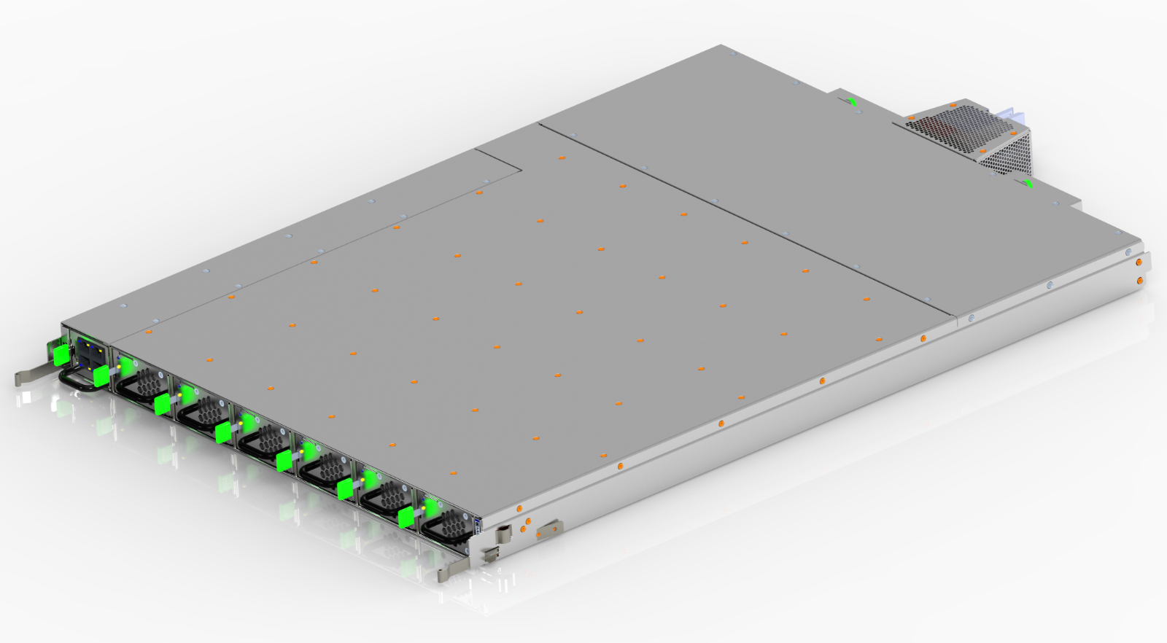

# Power shelf options

The following power shelves are introduced on this Spec according to the application:

## Power shelf option 1 – 6x 3kW PSU with dual cord (2x 20A NEC breaker upstream)

1 OU shelf with two AC power input.

6x 3kW rectifier slots.

Output power: 15kW with N+1 and dual cords.

Direct connect to tap-boxes/facility – no intermediate PDU.



## Power Shelf Option 2 – 6x 3kW PSU with Single Cord (32A IEC breaker upstream)

1U shelf with one AC power input.

6x 3kW rectifier slots.

Output power: 15kW with N+1 and single cord.

Direct connect to tap-box/facility – no intermediate PDU.



# Electrical requirements

## AC Electrical requirements

Power shelf ac input(s) are universal 7 pin connector to be configurable as:

* Star connection
* Delta Connection
* Single phase

For detail, see the ac input connector section.

* The input voltage to each phase-to-return shall be 200-277V nominal with +/- 10%.
* Frequency: 50/60 Hz
* The power module must withstand continuous exposure to 305Vac RMS input with no damage.

AC input shall have its earth ground connected to the chassis.

### Facility Protection

Datacenter facility protection rating is 2x 20A NEC circuit breaker for 2-feed 1U shelf and 32A IEC for single-feed 1U shelf. Short circuit current available is 25kA.

## DC Electrical requirements

Power shelf output voltage is specified as “Narrow-range 48V system.” For details, please see OCP ORv3 rectifier spec.

Power shelf SHALL have an output voltage with ripple & noise less than 500mV peak-to-peak with a 20MHz bandwidth. This applies along the entire length of the busbar without respect to the load or physical distribution of the trays. Compliance will be verified using a 0.1uF capacitor connected locally to the oscilloscope probe tips during this measurement. Ripple and noise are defined as periodic or random signals over a frequency band of 5Hz to 20MHz measured across a steady-state resistive load. Measurements shall be made differentially using an oscilloscope with 20Mhz bandwidth limit enabled.

48V return (negative) shall NOT be grounded to the power shelf frame.

## Rectifier physical addressing

Four rectifier signal pins are used for physical addressing. There are digital signals that should have internal pull up resistors inside the rectifier. On the power shelf, these pins can be grounded (0) on left open (1) to determine rectifier location.

## Monitoring & Control Interface

Each Power shelf shall include a monitoring module (PMI/PMC) to monitor and control various rectifier parameters. The monitoring module is connected to rack management controller or facility level monitoring through a monitoring & control interface.

Note it is required that if monitoring module fails, power system shall be able to operate normally.

PMI (Power monitoring Interface) diagram:

# Mechanical Requirements

## Power Shelf Assembly Dimensions

Power shelf options 1 and 2 are 1OU tall. The overall dimensions of the 1OU power shelf are 537mm x 46mm x 788.7 [Width x Height x Depth]

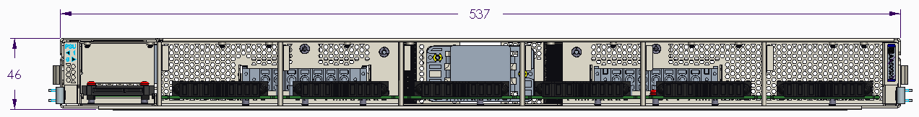

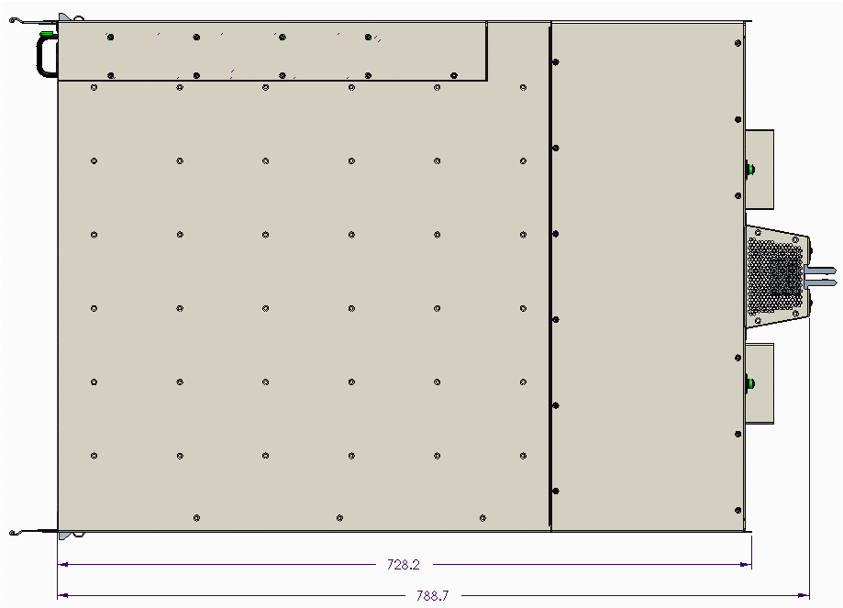

## ORV3 Rack Mounting Feature

The power shelf will be front mounted anywhere in the Open Rack V3 on OU pitch rails (please refer to the Open Rack V3 specifications for more design details). The design of the 48V Output connector allows it to be placed in any location in the rack.

Rack mounting features are of particular importance in the power shelf design since they assist in constraining the power shelf in X, Y, and Z directions and promotes solid electrical contact with the 48V busbar.

### Front Latch & Bumper

Please refer to the mechanical CAD for the locations of the front latch and bumper. Note that these serve separate functions and should not be a single part.

Latch shall be designed to withstand shocks seen during fully loaded rack shipping testing in a populated shelf. This shock limit is 16G, including margin. It is highly suggested to use SUS301 Stainless Steel, ¾ Hard.

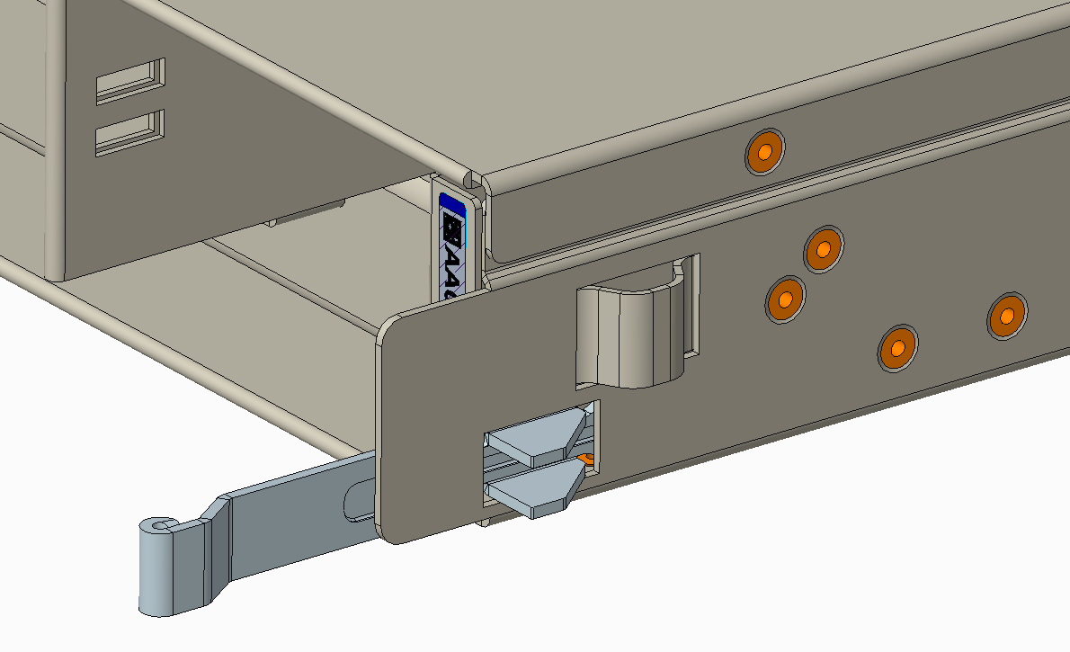

### Rear Stop

Please refer to the mechanical CAD for the geometry of the rear stop. This is required to interface properly with the ORV3 rack

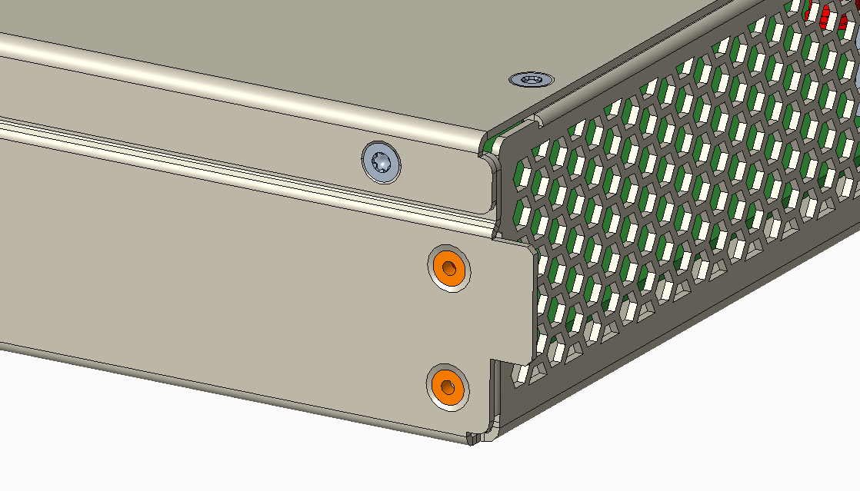

## Connectors

### AC Input connector

For the 1OU Shelf, please refer to the specification for the Open Rack V3 Power Shelf Universal Input Connector. This power shelf has either one or two such connectors (Facing from rear: Right side for EU, Right & Left Side for NA). Please refer to the mechanical drawing to identify the precise positioning of these connectors. Connector can come in either PCB mounted or cabled versions. Shown below is a drawing of the right-side PCB mounted male connector.

The following are preferred connector types for different shelf configurations in order to improve thermal performance:

NA Shelf (20A Input):

* PCB Mounted
* Cabled with 10 - 12 AWG wire

EU Shelf (32A Input):

* Cabled with 8 AWG wire

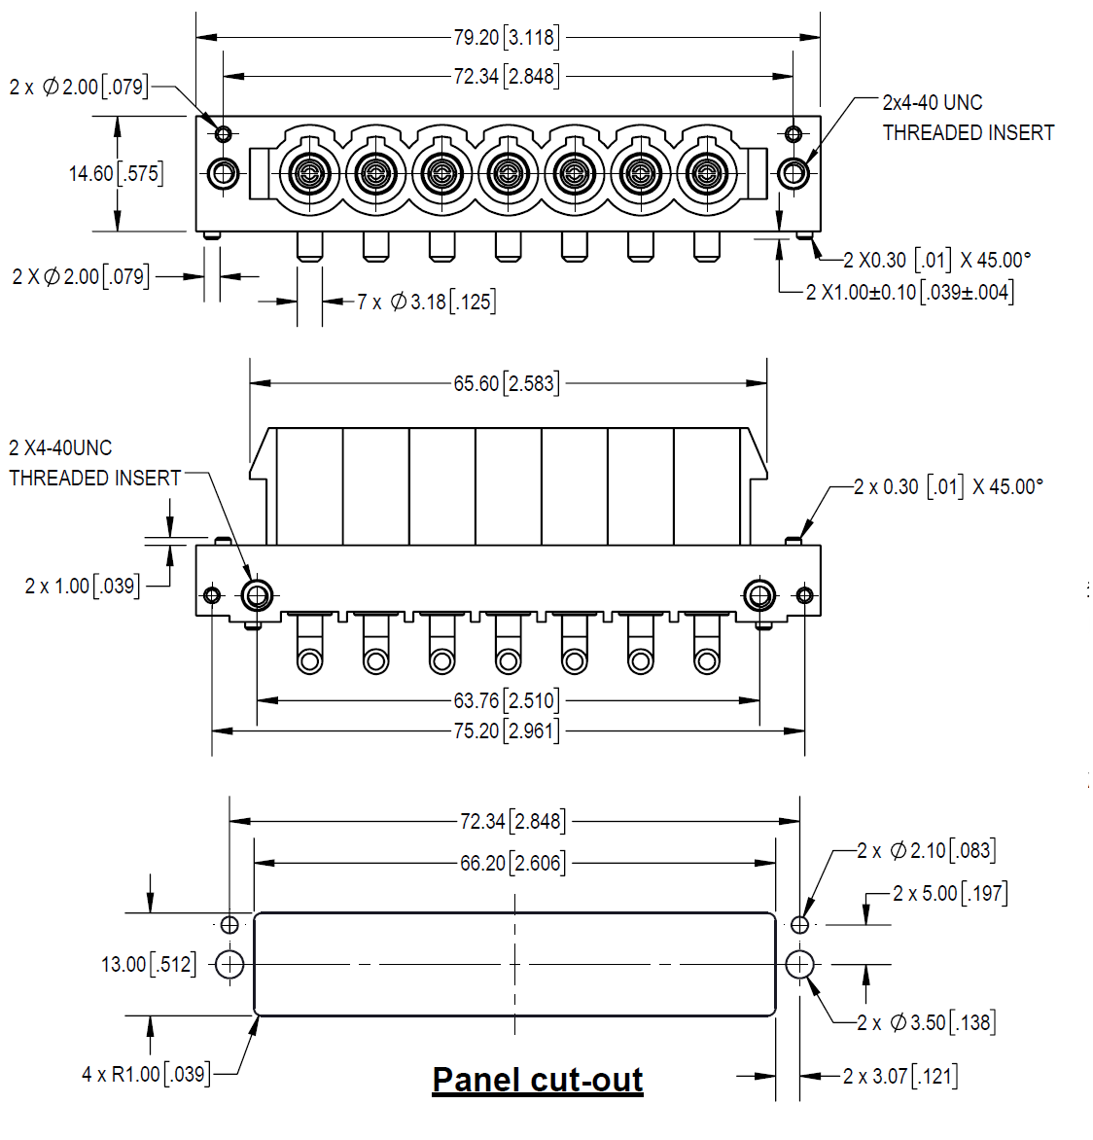

The female mating connector brings the AC power from the data center into the shelf. It is rated for 32A and is angled outwards, such that cables may be routed along the sides of the rack. Please see Open Rack V3 specifications for more details.



The shelf input connections are for the entry of the input power to the rectifiers. It’s a pluggable 7-pin connector that allows various input power configurations (star, delta, single phase.)

For details, please refer to “OCP ORv3 Universal Input Connector”. Please refer to the mechanical CAD for required positioning of this connector on the rear panel.

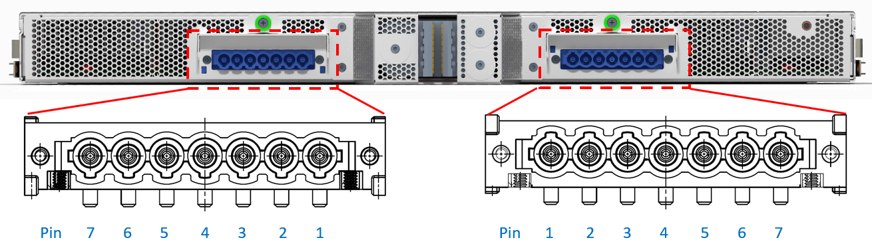

Example: Star Wire Configuration (NA on the left, EU on the right)

### DC Output connector

The power shelf DC output floating connector blind mates to the busbar in the rear side of the power shelf. This enables flexibility in:

* Placing power and battery shelves at any desired location on the rack.
* Adding more power and/or battery shelves as needed.

The DC Output connector shall make contact with the Open Rack V3 busbar. Please refer to the Open Rack V3 Power Shelf 48V Output Connector for more details. A drawing of the housing and recommended panel layout is shown below.

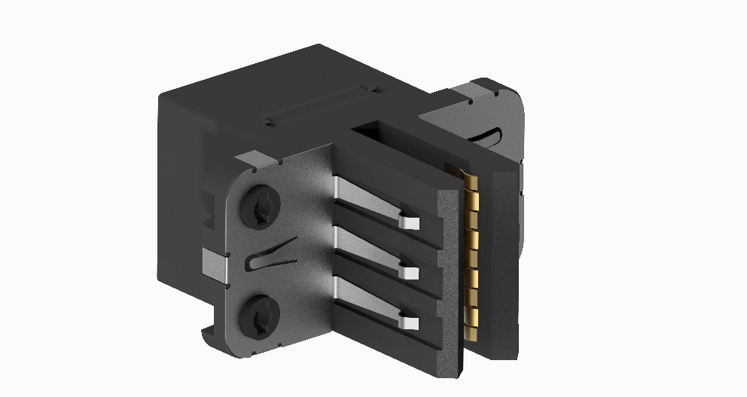

### Power Supply Connector

The chassis side of the rear blind mate connector of the PSU shall be Amphenol 10127400-01U1520LF or equivalent. This is a R/A receptacle, PwrBlade ULTRA HD connector with 3 low power pins, 25 signal pins, and 4 high power pins. Please refer to the drawing for more details. The connector positions (in all 6 or 12 locations) within the power shelf is fixed in x, y, and z direction according to the 3D drawing. This cannot be altered due to mix-and-match requirements for the power supplies into the shelf.

Rectifiers plug into the power shelf directly, and they shall be hot swappable while the rack is powered. Please refer to “OCP ORv3 PSU” for pinout signals.

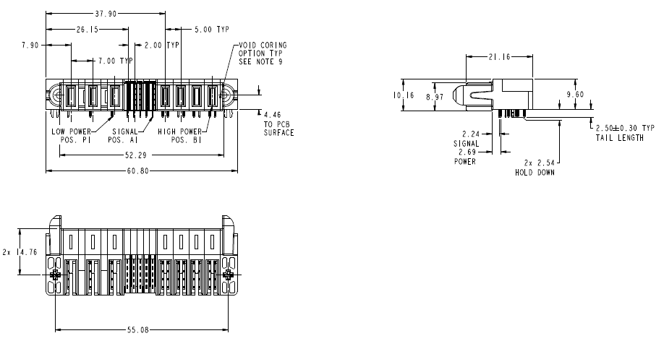

### PMI connector

The PMI is a blind-mate module with an edge card on one end. 2C card edge connector. The shelf side features a 2C card edge connector. The location of this connector is fixed, but the connector itself may either be mounted on a PCB or a panel-mounted cable. There are no specific requirements for the interface of this blind mate connector to the main shelf PCB. Please refer to the 3D drawing for the precise position.

PMI plugs into the BBU shelf directly, and it shall be hot swappable while the rack is powered. Please refer to “OCP ORv3 PMI” for connector pinout signals.

Approved connectors are:

* TE Sliver 2340326-01
* Amphenol Mini Cool Edge ME1008413401101
* Molex Edgeline Sliver 2086104157

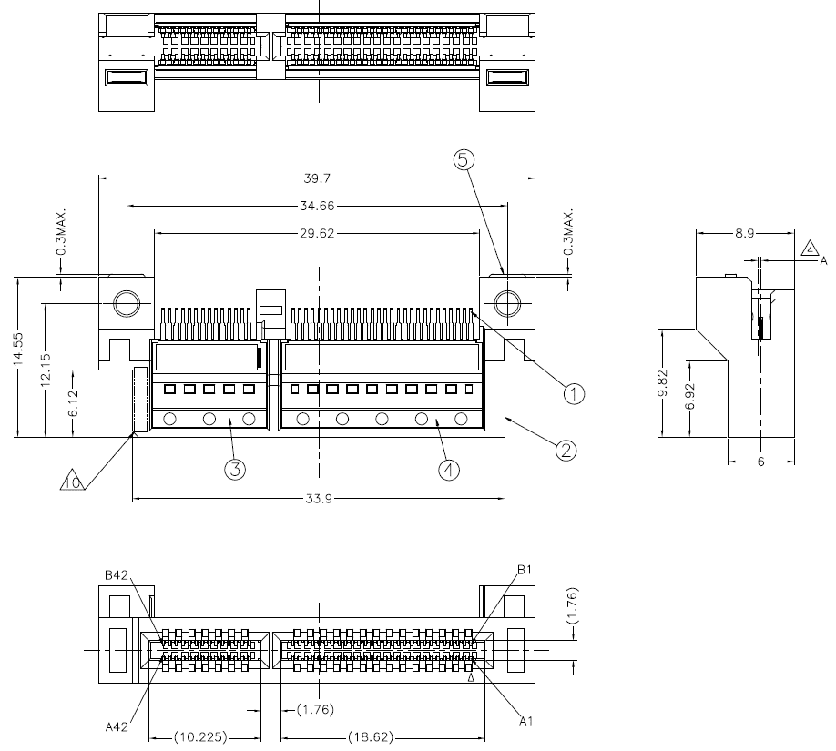

## Front Access

All 6 power supplies shall be toollessly accessible from the front and located in the positions defined in the 3D drawing. The PMI shall also be toollessly accessible from the front and located in the position defined on the 3D drawing.

## Construction

The power shelf can be welded, riveted or screwed together, consistent with meeting shock, vibration and maximum allowable deflection requirements. There shall be no sharp corners or edges.

When assembled into a rack, with rectifiers installed, maximum deflection of the rectifier shelf shall be less than 1.3 mm.

The rear cover of the power shelf shall be assembled using flathead screws. No rivets are allowed as the rear must be accessible for assembly and serviceability with a screwdriver

## Materials and Fasteners

The sheet metal material shall be steel, pre-plated hot-dip zinc coated, with 1.0mm - 1.2mm of thickness unless otherwise specified. Any plastic material used should meet UL 94-V0 specifications. It is highly suggested to use PCR (post-consumer recycled) plastic. The following PCR plastics have been qualified for use:

* GLite MBS-200BKR01
* GLite MBS-200GNR01
* Kingfa JH960-6950 C2B-S0759
* Kingfa JH960-6950 C7G-S0023
* Wistron WAM NCT50T#

## Labeling & Markings

Markings shall be placed on the rear of the power shelf that which terminal of the DC output connector on the shelf is - and which is +. Also, AC Input Connector (s) shall be marked accordingly. Markings are to be used as an assembly aid to ensure cables are assembled correctly. Preferred method is silk screening / pad printing.

Shelf labeling to be placed on the top side or other approved location.

## PSU Slot Blank

Any configuration that dictates the use of less than 6 PSUs in one shelf must include a PSU slot blank in order to properly channel airflow through the operating PSUs. The PSU slot blank features a latch identical to those used on the PSU module. Please reference “OCP Open Rack V3 PSU Module” for more details.

## Mechanical Drawings

# Thermal Requirements

## Operational

* For operating environmental conditions, please refer to section 7.
* Airflow direction: Front-to-back
* Exhaust temperature from upstream components/assemblies: Should not exceed 70°C and should be driven by operation of upstream components (rectifier and PMI).
* Thermal margin: Reserving adequate margins on components is critical. These margins should be defined with respect to de-rated values, as appropriate. Following are the requirements.
* Component thermal margin of ≥7% or ≥5°C up to 30°C inlet/ambient and 3050m (10,000ft) above sea-level. Target whichever value is larger.
* Component thermal margin of ≥4% or ≥3°C at greater than 30°C inlet/ambient and up to 3050m (10,000ft) above sea-level. Target whichever value is larger.
* Margin to de-rated temperatures should account for associated differences in reading and measurement location. Impact to reliability should also be considered when determining required margin.

## Thermal design requirements

* Sensor accuracy: For discrete and critical sensors (such as ambient temperature), an accuracy of ±2°C is required (≤±1°C is preferred). If a component does not have an integrated temperature sensor, and uses a proxy, need to target an accuracy ≤±5°C (≤±2°C is preferred). If this component is temperature sensitive, thermal margin requirements defined above should account for sensor inaccuracy.
* Back-pressure: Shelf design should accommodate compliance requirements while ensuring reasonable impact to upstream components. Rear panel design can significantly influence the amount of back-pressure upstream components have to overcome (such as the rectifiers). In general, targeting a back-pressure of ≤0.2 inches of water for a flow rate of 100cfm is highly recommended (at sea-level and flow through rectifier area only).
* Bus-bar power or DC output connection assembly: Termination of cables within the shelf as well as the clip/connector (to the rack bus-bar) mounting at the rear panel should be designed to ensure adequate cooling for compliance requirements (temperature difference as a function of current draw).
* Surface temperature: To make the shelf safe for handling in-operation, accessible surfaces should not exceed a temperature of 70°C.

# Environment/test requirements

* Gaseous Contamination: Severity Level G1 per ANSI/ISA 71.04-1985
* Ambient operating temperature range: -5°C to +45°C
* Operating and Storage relative humidity: 10% to 90% (non-condensing)
* Storage temperature range: -40°C to +70°C
* Transportation temperature range: -55°C to +85°C (short-term storage)
* Operating altitude with no de-ratings: 3050m (10,000 feet)
* Acoustic noise: Target sound pressure should not exceed 85dBA when fan modules are running at full speed and operating within the defined environmental envelope

## Vibration and Shock (non-packaged)

The “power shelf with PSUs and PMI module inside” shall meet vibration and shock test per EN 60068-2-6 and 60068-2-27, respectively, for both non-operating and operating condition, with the specifications listed below. During operating vibration and shock tests, the PSU shall exhibit full compliance to the specification without any electrical discontinuities.

During the non-operating tests, no damages of any kinds (included physical damages) should occur and they should not corrupt the functionalities of the PSU per the specifications.

Shock and Vibration tests are to be performed on soft tooled and hard tooled parts.

Vibration Non-Operating:

|  |  |
| --- | --- |
| Excitation Mode: | Sinusoidal |
| Test Frequency: | 5Hz to 500Hz  (5.0-9.0Hz) 6mm peak to peak  (9.0-500.0Hz) 1g |
| Amplitude: | 1g |
| Frequency Change Rate: | 1 octave / min |
| Test Directions: | 3 directions in space (x,y,z) |
| Duration: | 10 sweep cycles for each direction (2hours 13 minutes) |
| Test Temperature: | Room temperature |
| Electrical Work: | none |

Shock Non-Operating:

|  |  |
| --- | --- |
| Shock Pulse: | half sinus |
| Shock duration: | 11ms |
| Shock Amplitude: | 12g |
| Test Directions: | 6 directions |
| Number of Shocks: | 60 (10 per each direction) |
| Test Temperature: | Room temperature |
| Electrical Work: | None |

Vibration Operating:

|  |  |
| --- | --- |
| Excitation Mode: | Sinusoidal |
| Test Frequency: | 5Hz to 500Hz  (5.0-9.0Hz) 6mm peak to peak  (9.0-500.0Hz) 1g |
| Amplitude: | 0.5g |
| Frequency Change Rate: | 1 octave / min |
| Test Directions: | 3 directions in space (x,y,z) |
| Duration: | 10 sweep cycles for each direction (2hours 13 minutes) |
| Test Temperature: | Room temperature |
| Electrical Work: | Power supply in operation |

Shock Operating:

|  |  |
| --- | --- |
| Shock Pulse: | half sinus |
| Shock duration: | 11ms |
| Shock Amplitude: | 6g |
| Test Directions: | 6 directions |
| Number of Shocks: | 30 (5 per each direction) |
| Test Temperature: | Room temperature |
| Electrical Work: | Power supply in operation |

## Package Vibration, Drop and Compression

The power shelves (without PSUs) in their shipping package shall meet the following requirements:

|  |  |  |
| --- | --- | --- |
| Package Vibration | 1.146 Grms, 2-200-2 Hz, all three axes, Random Vibe | ISTA 3E 06-06 |
| Package Drop | 8-inch drop | ISTA 3E 06-06 |
| Package Compression | Maximum compression loading on a bulk pack | ASTM D 642-94 |

# Reliability and Quality

## Derating Design

A comprehensive stress analysis and derating design shall be performed for all **applicable parts** in the power shelf. The stress analysis shall include electrical, thermal, and mechanical stresses with actual measurements as applicable. The components in the power shelf design shall be properly derated and to meet the derating guideline as specified in IPC-9592B “Requirements for Power Conversion Devices for the Computer and Telecommunication Industries”, Appendix A or supplier’s own derating guideline.

## Reliability Prediction

Power shelves are to be used for the DMTBF test for the PSU using PSUs and power shelves from mix-source build.

## Design Failure Mode and Effect Analysis (DFMEA)

A comprehensive DFMEA shall be performed for the power shelf. The DFMEA report shall include a list of critical components, risk areas, and corrective actions taken.

## Reliability Tests

Power shelves are to be used for certain Reliability and Environmental tests with the PSU (i.e. DMTBF, Shock & Vibration, etc, etc)

## Sheet Metal Material and Zinc Whisker Implications

* Sheet Metal Chassis Material is hot-dip Zinc coated, JIS G3302
* SGCC (Z18 to Z22), with 1.0mm - 1.2mm of thickness. The ‘Z’ parameter defines the metal coating thickness: Z20 is for 40µm of thickness, and Z22 is for 43µm.
* The Japanese standard is ‘JIS G3302’, while the US standard is ‘ASTM A653’.
* Mechanical design shall prevent sharp edges and possible metal oxidation in the critical points of the sheet metal (e.g. in the cut & bends portions, etc.).
* Both chassis design and metal base material will not promote the growth and propagation of zinc and tin whiskers.
* Metal base materials with electro-zinc plating, or poor conductivity plating, are not allowed.
* Alloy materials are a possible option, while stainless steel is another possibility provided that it makes cost sense (both options are subject to Facebook approval)
* Aluminum material is not allowed for the enclosures.
* The chassis enclosure, as well as the whole electronics, shall meet certain contamination requirements (see ANSI spec at § 14)

## Manufacturing Quality and Production Tests

It is required to meet the quality process requirements as specified in IPC-9592B, Section 6 (“Quality Process”), which include PFMEA, statistical process control (SPC), corrective action process, yield control, materials traceability, product change notice (PCN), qualification of change, etc.

## Hipot and Ground Continuity Test

The PSU shall be tested 100% in production for both Hi-Pot (with the applicable limits for the AC leakage current) and ground continuity (per the applicable standard). Stamps shall be applied to the chassis proving that both tests passed in productions.

## DFT and DFM

The Vendor shall provide DFT and DFM reports at EVT and/or DVT phase as applicable.

## Quality Control Process

* All assembly inspection dimensions and tolerances in the drawings provided must be met.
* Incoming Quality: <0.1% rejections.
* CPK values should equal or exceed 1.33 (Pilot Build and Production) using a sample size equal to 32 for CPK measurement.
* CPK measurement should be performed on every batch/lot build of pilot and mass production. During production, weekly CPK reports must be sent to Facebook engineering team.
* The Vendor will implement a further quality control procedure during production, by sampling power shelves randomly from the production line and running full test to prove ongoing compliance to the requirements. Process shall be documented and submitted to Facebook prior to production. The relative reports will be ongoing submitted to Facebook.
* PCB boards are UL recognized components rated 94 V-0 and rated 130°C MOT.
* Multi-layers (> 2 layers) PCB boards are welcome for a better layout and simplification of the manufacturing process, however if they make sense for cost.

## Mass Production First Article Samples

Prior to final project release and mass production, the Vendor will submit to Facebook a good quantity (of PVT production pilot run verification samples, including the following documentation:

* All the pertinent development docs, production docs, and reports necessary to Facebook to release the product for mass production.
* The pilot samples shall be built in the allocated facility for mass production and use hardtooled chassis and parts (where applicable).
* Full spec compliance matrix, full test report, production line final test ‘pass’ tickets.
* Samples are shipped using the approved for production shipping box.
* The units are certified and safety label is applied (“Pending Certification” sticker may be allowed until the certification process is complete).

## Spec Compliance, Quality FA, Warranty

* The Vendor is responsible for the power shelf to meet the specifications as stand-alone unit as well as at system level, and for assuring that the power shelves shipped in production will conform to the specifications with no deviations.
* A specification compliance matrix and test report shall be submitted to Facebook for each PSU revision: EVT(P1), DVT(P2), and PVT (Pilot).
* The Vendor is responsible to exceed production quality standards achieved on the pilot run built without fluctuations.
* All failures from EVT, DVT, PVT are required to complete failure and root cause analysis and report corrective action prior to entering mass production.
* Failure analysis on defective RMA units shall be provided to Facebook with corrective action plan, within two weeks from when the units are received at the Vendor’s facility.
* The Vendor shall warrant the power supply for defects and workmanship for a period of three (3) years from the date of shipment when the device is operated within specifications. The warranty is fully transferable to any end user. A standard “VOID” warranty sticker may be applied.

## Mix-source Builds

Suppliers are required to conduct a mix-source build ideally at DVT using prime and 2nd source/alternate parts in the BOM. Samples from mix-source builds are to be used in all Reliability and Environmental tests for the power supply as would be applicable.

## Conformal Coating

Local automated, conformal coating shall be applied to critical areas of the boards to protect sensitive circuitries, using an atomized spray process (no dipping process is considered here). The thickness of the coating shall be ~50µm to ~150µm. The Vendor (mainly the ultimate Manufacturing Facility) shall demonstrate to possess good skills, experience, and long years of experience on automated conformal coating application and process. The main PCBA shall be partially conformal coated (top & bottom); critical board areas shall be agreed upon, typically the ac high- voltage input section at shelf level, like the AC input, board-mount connector area.

## Insulator

An insulator will/might be required between chassis and solder side of the shelf main PCBA. This to prevent shorting/arcing between the chassis (i.e. earth ground) to any of the line inputs due to conductive loose parts or foreign materials, etc.

# Compliance requirements

The power supply shelf shall be designed for compliance to allow worldwide deployment. Additionally, the manufacturer is fully responsible for:

* ensuring the complete compliance of the power supply shelf in the environment it is intended to function (as described by the Rack Spec)
* maintaining and updating the power supply shelf safety reports to current requirements and all new released requirements.
* all design and recertification costs required to update the power supply to meet the new
* requirements.
* Meeting EMC requirements
* Meeting Safety requirements

The manufacturer is responsible for obtaining the safety certifications specified below.

## Safety Standards

The product is to be designed to comply with the latest edition, revision, and amendment of the following standards. The product shall be designed such that the end user could obtain the safety certifications: UL 62368-1, IEC 62368-1 and EN 62368-1; hazard-based performance standard for Audio video, IT & Communication Technology Equipment

The manufacturer shall obtain the following safety certifications for the power supply shelf as applicable. Only requirements that absolutely rely on or are affected by the system may be left to the system level evaluation [i.e. minimize Conditions of Acceptability]. Below are common requirements for North America and Europe. For other countries, different certifications may be required:

* UL or an equivalent NRTL for the US with follow-up service (e.g. UL or CSA).
* CB Certificate and test report issued by CSA, UL, VDE, TUV or DEMKO
* CE Marking for EU

### Component Safety requirements

Following are the safety requirements for major components:

* All Fans shall have the minimum certifications: UL and TUV or VDE.
* All current limiting devices shall have UL and TUV or VDE certifications and shall be suitable rated for the application where the device in its application complies with IEC/UL 62368-1.
* All printed wiring boards shall be rated UL94V-0 and be sourced from a UL approved printed wiring board manufacturer.
* All connectors shall be UL recognized and have a UL flame rating of UL94V-0.
* All wiring harnesses shall be sourced from a UL approved wiring harness manufacturer. SELV Cable to be rated minimum 80V, 130C.
* Product safety label must be printed on UL approved label stock and printer ribbon. Alternatively, labels can be purchased from a UL approved label manufacturer.
* The product must be marked with the correct regulatory markings to support the certifications that are specified in this document.

## EMC Requirements

The power shelf shall meet the following requirements in the latest edition of standards when operating under typical load conditions and with all ports fully loaded;

The Power supply integrated into the shelf is called the component power supply. Manufacturer shall provide the proof of compliance for the component power supply that are required for spare parts shipment. The component power supply shall not contribute any noncompliant conditions to the end-use product.

If at any time it is found that a supplier’s component power supply causes the end-use product to fail emissions and/or immunity testing, the supplier will be instructed to investigate and resolve the problem.

The power shelf shall have minimum 6dB margin from the Class A limit for the radiated and conducted emissions. Depending on the system manufacturer’s design goals and business needs, more margin may be required when it is integrated into the final end system.

The following EMC Standards (the latest version) are applicable to the product.

* FCC /ICES-003
* CISPR 32/EN55032
* CISPR 35/EN55035 - Immunity
* EN61000-3-2 - Harmonics
* EN61000-3-3 - Voltage Flicker
* VCCI
* KN 32 and KN35

Each individual basic standard for immunity test has the following minimum passing requirement. Higher level of passing criteria may be applied depending on the system manufacturer’s design goals and business needs.

* EN61000-4-2 Electrostatic Discharge Immunity
  + Contact discharge: >5.6kV
  + Air discharge: >11.2kV
* EN61000-4-3 Radiated Immunity
  + > 3V/m
* EN61000-4-4 Electrical Fast Transient Immunity
  + AC Power Line: >1kV
  + Signal Line: >0.5kV
* EN61000-4-5 Surge
  + AC Power Line: >2kV (Line-to-line), >4kV (Line-to-earth)
  + Signal Port: >1kV
* EN61000-4-6 Immunity to Conducted Disturbances
  + DC Power Line: > 3Vrms
* EN61000-4-8 Power Frequency Magnetic Field Immunity, when applicable
  + > 1A/m
* EN61000-4-11 Voltage dip and sag

## Environmental Compliance

The power shelf (including all components inside) shall comply with the following minimum environmental requirement and manufacturer shall provide full material disclosure, Declaration of Conformity and technical documentations to demonstrate compliance. The system manufacture may have additional requirements depending on its design goals and business needs.

* RoHS Directive (2011/65/EU and 2015/863/EU); aims to reduce the environmental impact of EEE by restricting the use of certain substances during manufacture
* REACH Regulation (EC) No 1907/2006; registration with the European Chemicals Agency (ECHA), evaluation, authorization and restriction of chemicals.
* Halogen Free: IEC 61249-2-21, Definition of Halogen Free, 900ppm for Br or CI, or 1500ppm combined
* US SEC conflict mineral regulation to source mineral materials from socially responsible countries, if applicable
* Waste Electrical and Electronic Equipment (“**WEEE**”) Directive (2012/19/EU) if applicable; aims to reduce the environmental impact of EEE by restricting the use of certain substances during manufacture
* The vendor shall provide the declaration of compliance document stating that a product doesn't contain any substances regulated by EPA 40 CFR751
* Refer to FBPN: 18-000142 for more detail environmental compliance requirements

## Documentation

The manufacturer shall provide reproducible copies of all pertinent documentation relating to the following:

* Product Information
* Bill of Materials
* Schematics
* functional test report
* Final Compliance Approval
* NRTL certificate and report, Conditions of Acceptability and test report plus User documentation that explains safe installation and operating procedures.
* CB Certificate and report, including schematics
* Manufacturer’s Declaration of Conformity to EN 62368-1, EN55032, EN55035 and ROHS
* FCC Part 15 Class A and CISPR32 Class A test data
* Declaration of Conformity to EN 61000-3-2 Class A and test report including waveforms and harmonic output levels.
* Other applicable certificates required by the system manufacturer.

# Appendix A - Checklist for IC approval of this Specification (to be completed by contributor(s) of this Spec)

Complete all the checklist items in the table with links to the section where it is described in this spec or an external document.

|  |  |  |
| --- | --- | --- |
| **Item** | **Status or Details** | **Link to detailed explanation** |
| Is this contribution entered into the OCP Contribution Portal? | Yes | If no, please state reason. |
| Was it approved in the OCP Contribution Portal? | Yes | If no, please state reason. |
| Is there a Supplier(s) that is building a product based on this Spec? (Supplier must be an OCP Solution Provider) | Yes | List Supplier Name(s)  Delta |
| Will Supplier(s) have the product available for GENERAL AVAILABILITY within 120 days? | No | If more time is required, please state the timeline and reason for extension request.  Please have each Supplier fill out Appendix B. |

# 