

Open Rack V3 Power Monitoring Interface (PMI) Module

Rev: 1.0

08/24/2022

Authors:

Hamid Keyhani

Dmitriy Shapiro

David Sun

# License (OCP CLA Option)

Contributions to this Specification are made under the terms and conditions set forth in **Open Compute Project Contribution License Agreement (“OCP CLA”) (“**Contribution License”) by:

**Meta Platforms**

You can review the signed copies of the applicable Contributor License(s) for this Specification on the OCP website at <http://www.opencompute.org/products/specsanddesign>

Usage of this Specification is governed by the terms and conditions set forth in  **Open Web Foundation Final Specification Agreement (“OWFa 1.0”)**

You can review the applicable Specification License(s) executed by the above referenced contributors to this Specification on the OCP website at http://www.opencompute.org/participate/legal-documents/

**Note**: The following clarifications, which distinguish technology licensed in the Contribution License and/or Specification License from those technologies merely referenced (but not licensed), were accepted by the Incubation Committee of the OCP:

None

NOTWITHSTANDING THE FOREGOING LICENSES, THIS SPECIFICATION IS PROVIDED BY OCP "AS IS" AND OCP EXPRESSLY DISCLAIMS ANY WARRANTIES (EXPRESS, IMPLIED, OR OTHERWISE), INCLUDING IMPLIED WARRANTIES OF MERCHANTABILITY, NON-INFRINGEMENT, FITNESS FOR A PARTICULAR PURPOSE, OR TITLE, RELATED TO THE SPECIFICATION. NOTICE IS HEREBY GIVEN, THAT OTHER RIGHTS NOT GRANTED AS SET FORTH ABOVE, INCLUDING WITHOUT LIMITATION, RIGHTS OF THIRD PARTIES WHO DID NOT EXECUTE THE ABOVE LICENSES, MAY BE IMPLICATED BY THE IMPLEMENTATION OF OR COMPLIANCE WITH THIS SPECIFICATION. OCP IS NOT RESPONSIBLE FOR IDENTIFYING RIGHTS FOR WHICH A LICENSE MAY BE REQUIRED IN ORDER TO IMPLEMENT THIS SPECIFICATION. THE ENTIRE RISK AS TO IMPLEMENTING OR OTHERWISE USING THE SPECIFICATION IS ASSUMED BY YOU. IN NO EVENT WILL OCP BE LIABLE TO YOU FOR ANY MONETARY DAMAGES WITH RESPECT TO ANY CLAIMS RELATED TO, OR ARISING OUT OF YOUR USE OF THIS SPECIFICATION, INCLUDING BUT NOT LIMITED TO ANY LIABILITY FOR LOST PROFITS OR ANY CONSEQUENTIAL, INCIDENTAL, INDIRECT, SPECIAL OR PUNITIVE DAMAGES OF ANY CHARACTER FROM ANY CAUSES OF ACTION OF ANY KIND WITH RESPECT TO THIS SPECIFICATION, WHETHER BASED ON BREACH OF CONTRACT, TORT (INCLUDING NEGLIGENCE), OR OTHERWISE, AND EVEN IF OCP HAS BEEN ADVISED OF THE POSSIBILITY OF SUCH DAMAGE.

# **Table of Contents**

License (OCP CLA Option) 2

**Table of Contents** 3

**Revision History** 4

**1.** **Scope** 5

**2.** **PMI Overview** 5

**3.** **Electrical requirements** 6

**3.1** **4x RJ45 Connectors** 6

**3.2** **Edge Connector** 7

**3.3** **Filtering** 9

**4.** **Mechanical requirements** 10

**4.1** **PMI Physical Dimensions** 11

**4.2** **Construction** 11

**4.3** **Latch and Handle Requirements** 11

**4.4** **EMI Gaskets** 11

**4.5** **Labeling & Markings** 11

**4.6** **RJ45 Connector** 11

**4.7** **Blind Mate Connector** 12

**4.8** **Mechanical Drawings** 14

**5.** **Compliance requirements** 15

**5.1** **Safety Standards** 15

**5.2** **EMC Requirements** 15

**5.3** **Environmental Compliance** 15

**5.4** **​Documentation** 15

**6.** **Serviceability** 15

**6.1** **Required collateral** 15

**6.2** **FRU information** 15

**6.3** **PCB information** 15

**7.** **Thermal** 16

**8.** **Vibration and Shock (non-packaged)** 17

**9.** **Package Vibration, Drop and Compression** 17

# **Revision History**

|  |  |  |  |
| --- | --- | --- | --- |
| Date | Version | Change By | Comments |
| 04/22/2021 | 0. 5 | hamidk@ | Shared Modbus for PSU/BBU  Dedicated PMbus for each PSU/BBU  2x RJ45 connectors for Modbus  2x RJ45 connectors for shelf paralleling |
| 05/06/2021 | 0.51 | hamidk@ | Changed pin 6 of RJ45 #2 as GND. |
| 05/24/21 | 0.52 | hamidk@ davidsun@ | Add CAN+/- and SYNC_STOP_L signal pins in RJ45#3/#4 and Edge connector for BBU shelves parallel operation. |
| 07/27/21 | 0.53 | dmshapir@  jfern@ | Section 4.1: Updated picture showing proper dimensions  Added Section 4.2-4.5  Section 4.6: Added Amphenol PN  Section 4.7: Reworded, Added Amphenol & Molex PN  Added Section 4.8 Mechanical Drawings  Added Sections 6-9  Section 7: Rewording to eliminate reference to PMC; updated back-pressure value |
| 12/1/2021 | 0.54 | davidsun@  hamidk@ | Section 3.1 Adjusted pin assignment of RJ45 #3/#4 CAN_H(pin5->pin7), CAN_L(pin6->pin8), STNC_STOP_L(pin7->pin5), RSVD (pin8->pin6) |
| 01/20/2022 | 0.55 | davidsun@  hamidk@ | Added section 3.3 filtering |
| 08/24/2022 | 1.0 | Ted Tang | Updated to comply OCP specification template |

# **Scope**

This document defines the technical specifications for an Open Rack V3 Power Monitoring Interface (PMI) Module used in the Open Compute Project.

# **PMI Overview**

PMI is an extension module, which brings MODBUS of the PSU/BBUs directly out for upstream communication. PMI sits on Open Rack V3 Power and Battery Shelves. On one end, in has communication with the PSU or BBUs – through sliver straddle connector. On the other end, interacts with centralized system through the use of RJ45 connectors.

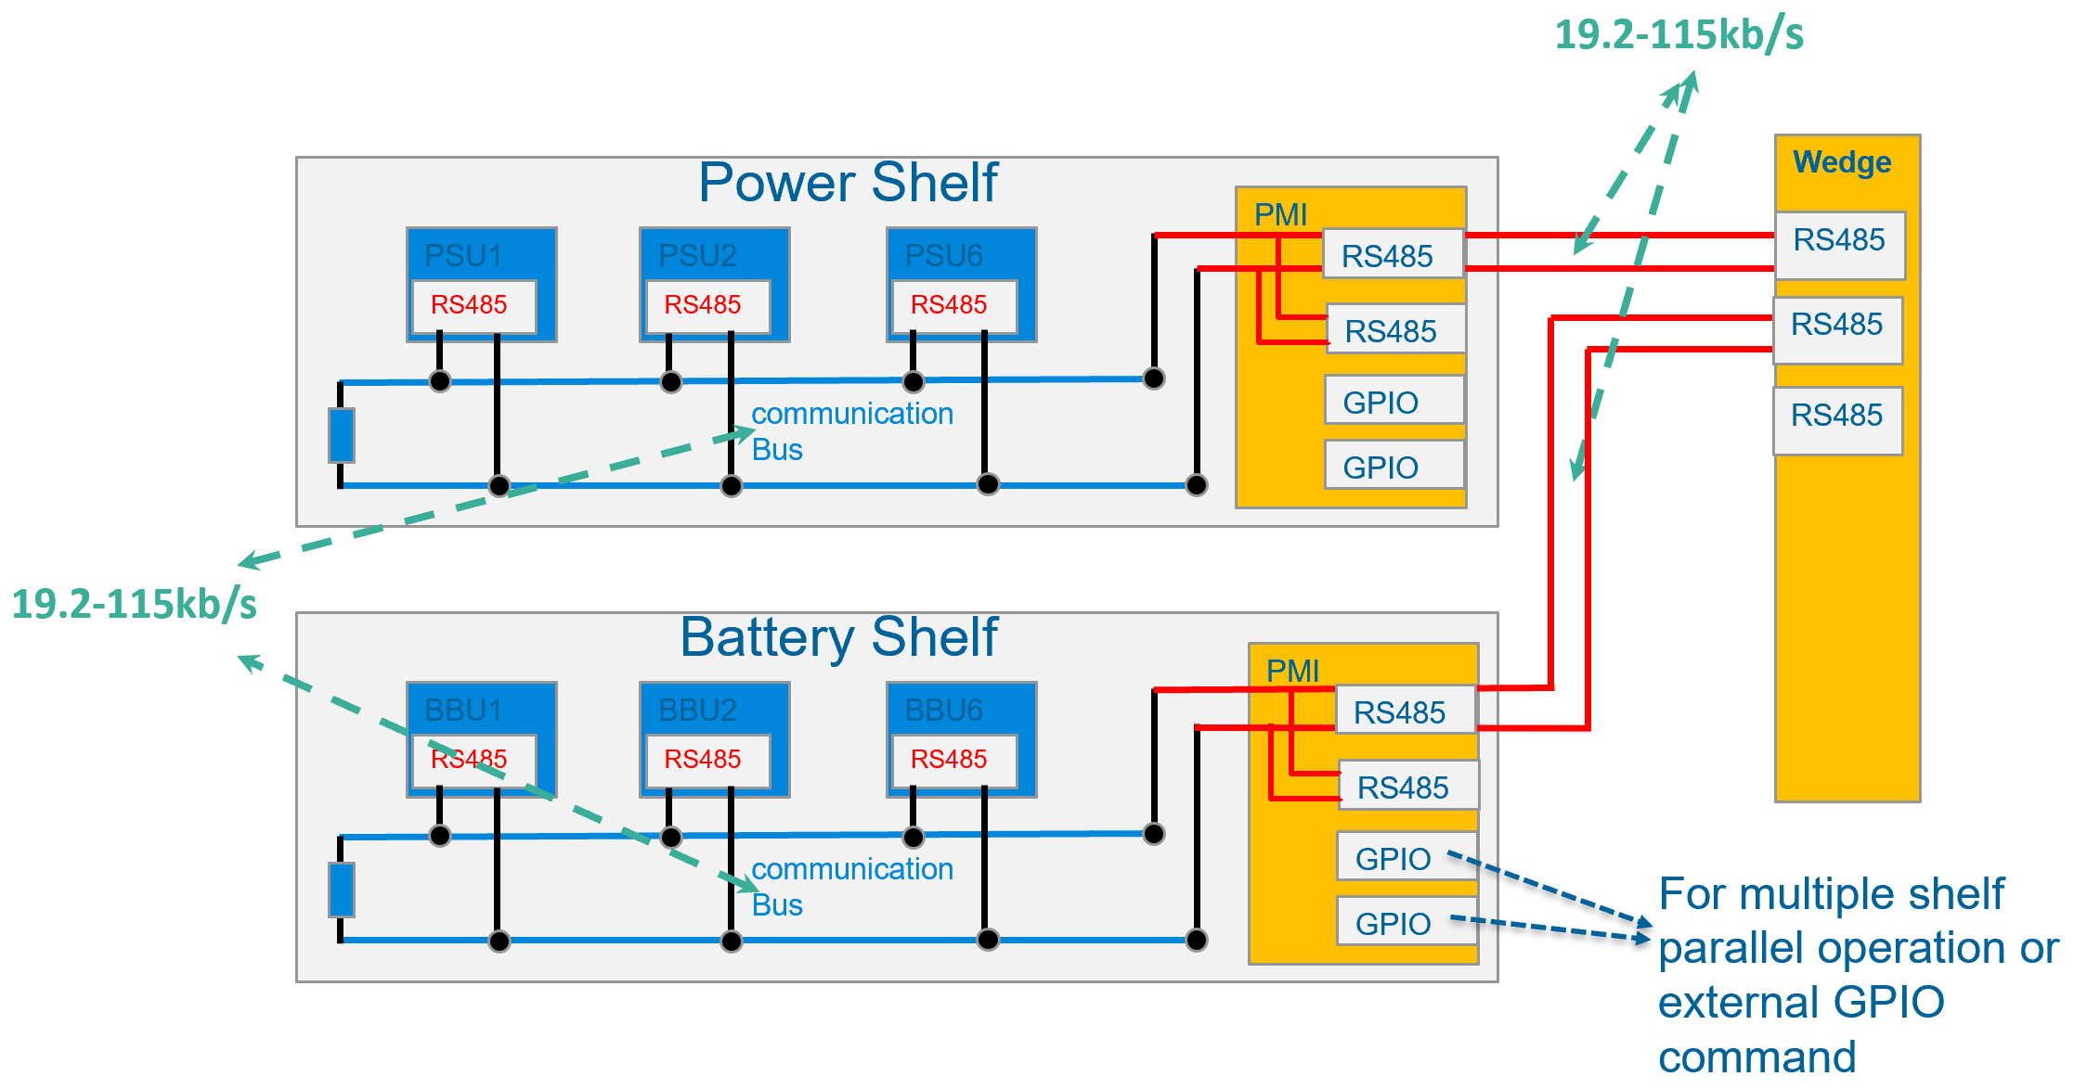

# **Electrical requirements**

## **4x RJ45 Connectors**

The PMI shall contain four RJ45 connectors located on the bulkhead of the assembly. The pinouts of the four connectors are shown below. The RJ45 location shall be defined in the mechanical section.

Looking from the front, Top left RJ45 is #1, Top right is #2, bottom left is #3, bottom right is #4.

RJ45 #1

|  |  |  |
| --- | --- | --- |
| **Pin** | **Wire color** | **Function** |
| 1 | White/Orange | GND |
| 2 | Orange | PLS |
| 3 | White/Green | BKP |
| 4 | Blue | RS485A |
| 5 | White/Blue | RS485B |
| 6 | Green | RS485_Addr2 |
| 7 | White/Brown | RS485_Addr1 |
| 8 | Brown | RS485_Addr0 |

RJ45 #2

|  |  |  |
| --- | --- | --- |
| **Pin** | **Wire color** | **Function** |
| 1 | White/Orange | GND |
| 2 | Orange | PLS |
| 3 | White/Green | BKP |
| 4 | Blue | RS485A |
| 5 | White/Blue | RS485B |
| 6 | Green | GND |
| 7 | White/Brown | RS485_Addr1 |
| 8 | Brown | RS485_Addr0 |

RJ45 #3 and RJ45#4

|  |  |  |
| --- | --- | --- |
| **Pin** | **Wire color** | **Function** |
| 1 | White/Orange | ISHARE |
| 2 | Orange | GND |
| 3 | White/Green | SYNC_START_L |
| 4 | Blue | VOUT_SEL |
| 5 | White/Blue | SYNC_STOP_L |
| 6 | Green | RSVD |
| 7 | White/Brown | CAN_H |
| 8 | Brown | CAN_L |

## **Edge Connector**

There are several signals on the edge connector. Yellow signals have no use-case currently, for future expansions. All other signals are routed in the power/battery shelf backplanes.

|  |  |  |  |
| --- | --- | --- | --- |
| **Pin #** | **Signal Name** | **I/O** | **Description** |
| A1 | ADDR_ID_0 | I | Shelf ID  000 1U power shelf  001 Battery shelf |
| B1 | ADDR_ID_1 | I |
| A2 | ADDR_ID_2 | I |
| B2 | GND | I | Ground |
| A3 | ALERT_0_N | I | PSU/BBU Alert |
| B3 | ALERT_1_N | I | PSU/BBU Alert |
| A4 | ALERT_2_N | I | PSU/BBU Alert |
| B4 | ALERT_3_N | I | PSU/BBU Alert |
| A5 | ALERT_4_N | I | PSU/BBU Alert |
| B5 | ALERT_5_N | I | PSU/BBU Alert |
| A6 | ALERT_6_N | I | PSU/BBU Alert |
| B6 | ALERT_7_N | I | PSU/BBU Alert |
| A7 | ALERT_8_N | I | PSU/BBU Alert |
| B7 | ALERT_9_N | I | PSU/BBU Alert |
| A8 | ALERT_10_N | I | PSU/BBU Alert |
| B8 | ALERT_11_N | I | PSU/BBU Alert |
| A9 | GND | I | Ground |
| B9 | RESET_0 | O | PSU/BBU Reset |
| A10 | RESET_1 | O | PSU/BBU Reset |
| B10 | RESET_2 | O | PSU/BBU Reset |
| A11 | RESET_3 | O | PSU/BBU Reset |
| B11 | RESET_4 | O | PSU/BBU Reset |
| A12 | RESET_5 | O | PSU/BBU Reset |
| B12 | RESET_6 | O | PSU/BBU Reset |
| A13 | RESET_7 | O | PSU/BBU Reset |
| B13 | RESET_8 | O | PSU/BBU Reset |
| A14 | RESET_9 | O | PSU/BBU Reset |
| B14 | RESET_10 | O | PSU/BBU Reset |
| A15 | RESET_11 | O | PSU/BBU Reset |
| B15 | GND | I | Ground |
| A16 | PLS | I | PSU/BBU Power Loss Siren |
| B16 | BKP | I | PSU/BBU BKP |
| A17 | RS485_Addr0 | O | PSU/BBU MODBUS address |
| B17 | RS485_Addr1 | O | PSU/BBU MODBUS address |
| A18 | RS485_Addr2 | O | PSU/BBU MODBUS address |
| B18 | RS485A | I/O | Shared PSU/BBU MODBUS |
| A19 | RS485B | I/O | Shared PSU/BBU MODBUS |
| B19 | I2C_SDA_0 | I/O | PSU/BBU #0 PMBUS |
| A20 | I2C_CLK_0 | I/O | PSU/BBU #0 PMBUS |
| B20 | I2C_SDA_1 | I/O | PSU/BBU #1 PMBUS |
| A21 | I2C_CLK_1 | I/O | PSU/BBU #1 PMBUS |
| B21 | I2C_SDA_2 | I/O | PSU/BBU #2 PMBUS |
| A22 | I2C_CLK_2 | I/O | PSU/BBU #2 PMBUS |
| B22 | I2C_SDA_3 | I/O | PSU/BBU #3 PMBUS |
| A23 | I2C_CLK_3 | I/O | PSU/BBU #3 PMBUS |
| B23 | I2C_SDA_4 | I/O | PSU/BBU #4 PMBUS |
| A24 | I2C_CLK_4 | I/O | PSU/BBU #4 PMBUS |
| B24 | I2C_SDA_5 | I/O | PSU/BBU #5 PMBUS |
| A25 | I2C_CLK_5 | I/O | PSU/BBU #5 PMBUS |
| B25 | I2C_SDA_shelf | I/O | I2C for Shelf Temp and FRU |
| A26 | I2C_CLK_shelf | O | I2C for Shelf Temp and FRU |
| B26 | GPIO2 | I/O |  |
| A27 | GPIO3 | I/O |  |
| B27 | GPIO4 | I/O |  |
| A28 | GPIO5 | I/O |  |
| B28 | GPIO6 | I/O |  |
| A29 | GPIO7 | I/O |  |
| B29 | GPIO8 | I/O |  |
| A30 | **CAN_H** | I/O |  |
| B30 | **CAN_L** | I/O |  |
| A31 | SYNC_STOP_L | I/O |  |
| B31 | GND | O | Ground |
| A32 | ISHARE | A | PSU/BBU Current Sharing |
| B32 | SYNC_START_L | I/O | PSU/BBU Sync Start |
| A33 | VOUT_SEL | O | PSU/BBU Vout Select |
| B33 | P3V3_shelf | O | 3.3V for shelf I2C |
| A34 | GND | O | Ground |
| B34 | ADC0 | A |  |
| A35 | ADC1 | A |  |
| B35 | ADC2 | A |  |
| A36 | ADC3 | A |  |
| B36 | ADC4 | A |  |
| A37 | ADC5 | A |  |
| B37 | ADC6 | A |  |
| A38 | ADC7 | A |  |
| B38 | Power_KILL | I | Power Kill, short pin  Connected to GND on the shelf. |
| A39 | RSVD | - | Reserved |
| B39 | RSVD | - | Reserved |
| A40 | P48V_RTN (GND) | I | Ground |
| B40 | P48V_RTN (GND) | I | Ground |
| A41 | NC (clearance) | - | No Connect |
| B41 | NC (clearance) | - | No Connect |
| A42 | P48V_IN | I | 48V Power In |
| B42 | P48V_IN | I | 48V Power In |

## **Filtering**

In order to meet compliance requirements, including EMC and ESD, the following filters may needed to be included:



# **Mechanical requirements**

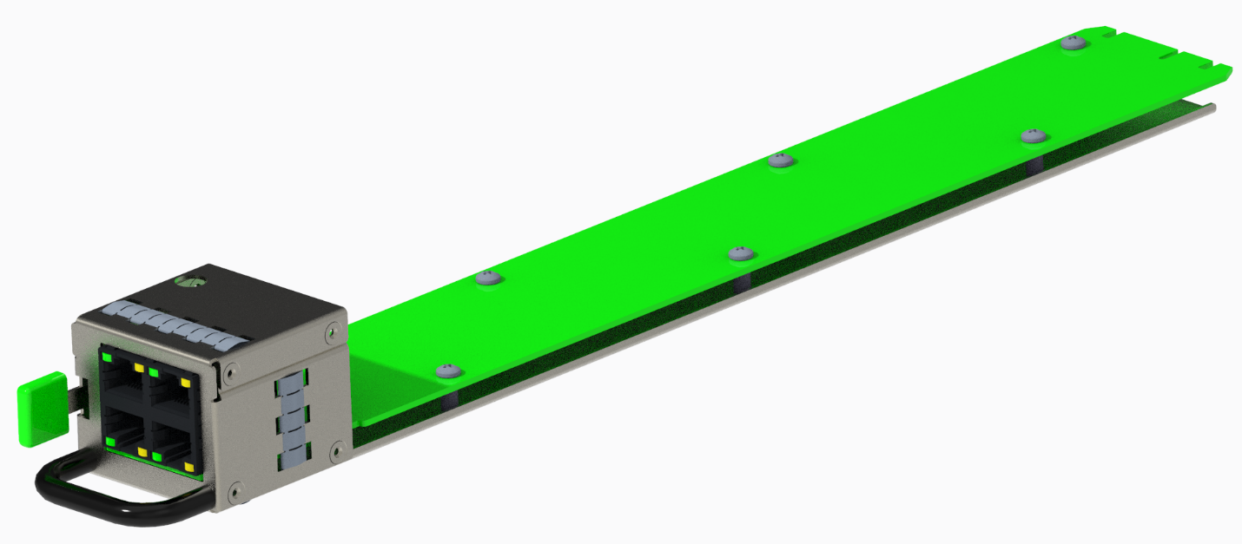

## **PMI Physical Dimensions**

The PMI is 39.7mm x 48mm x 350mm [Width x Height x Depth]

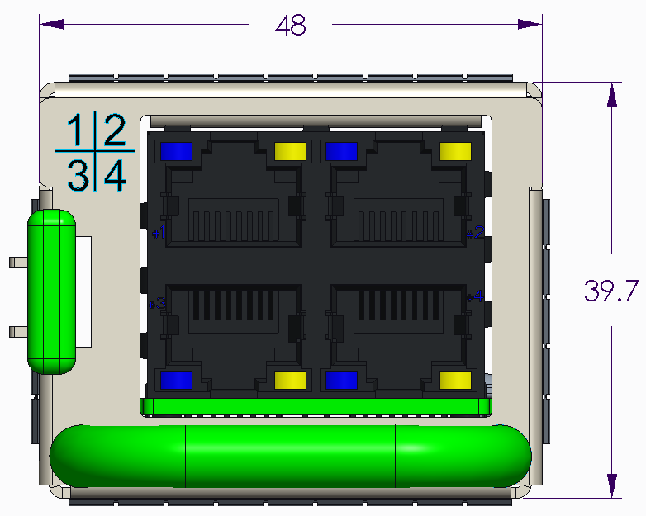 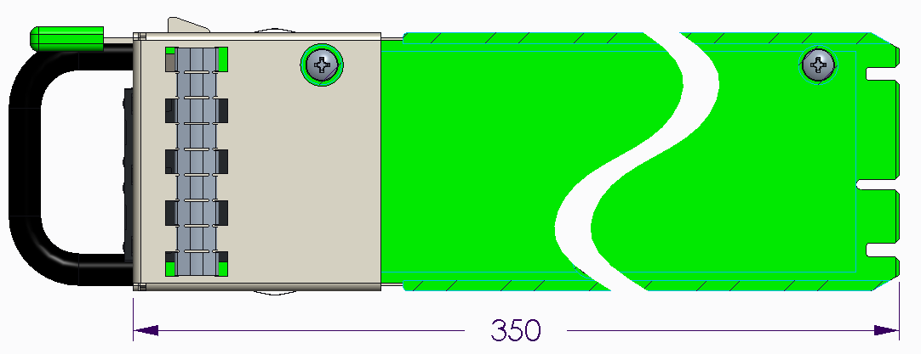

## **Construction**

The PMI base can be welded, riveted, or screwed together, consistent with meeting shock and vibration requirements. There shall be no sharp corners or edges.

The sheet metal material shall be pre-plated hot-dip zinc coated, with 0.8-1.0mm of thickness.

## **Latch and Handle Requirements**

A latch and handle are required for PMI removal and installation. The latch shall be attached in the location shown on the mechanical drawing, to interface with the cutout in the chassis. The latch design may vary, but the finger interface of the latch must be Pantone 375C (Green).

The handle is to be designed so it does not interfere with the removal and insertion of cables into the RJ45 connectors. Handle touch points to be Pantone 375C (Green).

## **EMI Gaskets**

EMI gaskets are to be placed on the left & right and/or top & bottom sides of the PMI. The main purpose of the gaskets is for PMI module to shelf grounding and secondary purpose is for EMI containment. Gaskets are to be placed towards the front of the PMI so they make full contact with the walls of the shelf.

## **Labeling & Markings**

Markings shall be placed on the front of the PMI module to indicate RJ-45 connector positions. Preferred method is silk screening / pad printing.

## **RJ45 Connector**

In the front of the PMI, there is a single 4x RJ45 connector. This is a modular jack connector in a 2x2 configuration of RJ45s with LEDs. The MPN shall be TE 2041376-2, Amphenol RJSAE-J384-04 or equivalent. Note that this connector comes with spring fingers. These must contact the PMI chassis in order to provide sufficient EMI sealing.

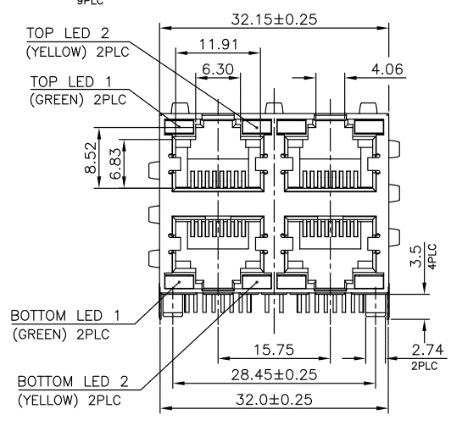

## **Blind Mate Connector**

The PCB (card edge) of the PMI module blind mates into a 2C connector on the shelf side. The location of this connector is fixed, but the connector itself may either be mounted on a PCB or a panel-mounted cable. There are no specific requirements for the interface of this blind mate connector to the main shelf PCB. Please refer to the ORV3 Power Shelf or ORV3 BBU Shelf specification for more details on this.

Approved connectors are:

* TE Sliver 2340326-01
* Amphenol Mini Cool Edge ME1008413401101
* Molex Edgeline Sliver 2086104157

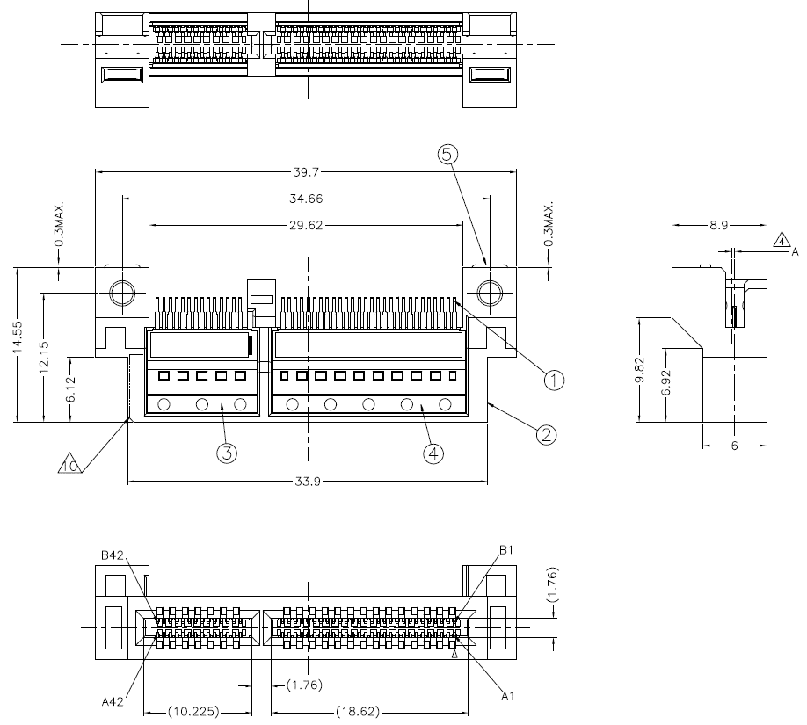

## **Mechanical Drawings**

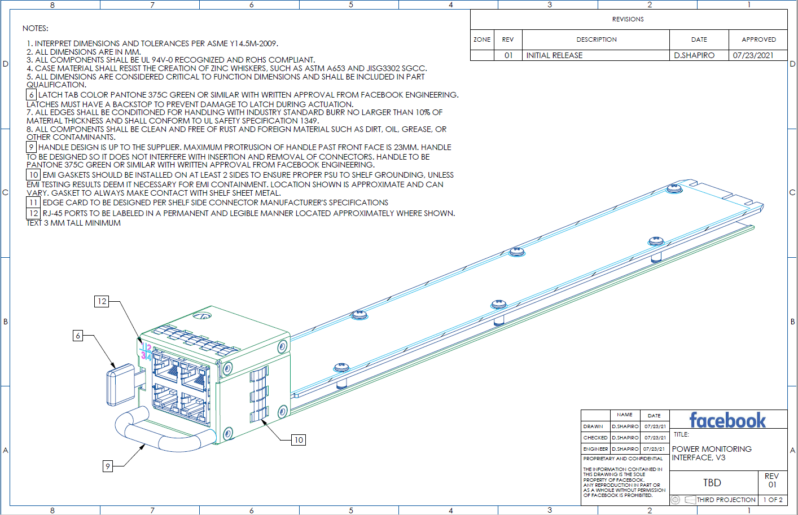

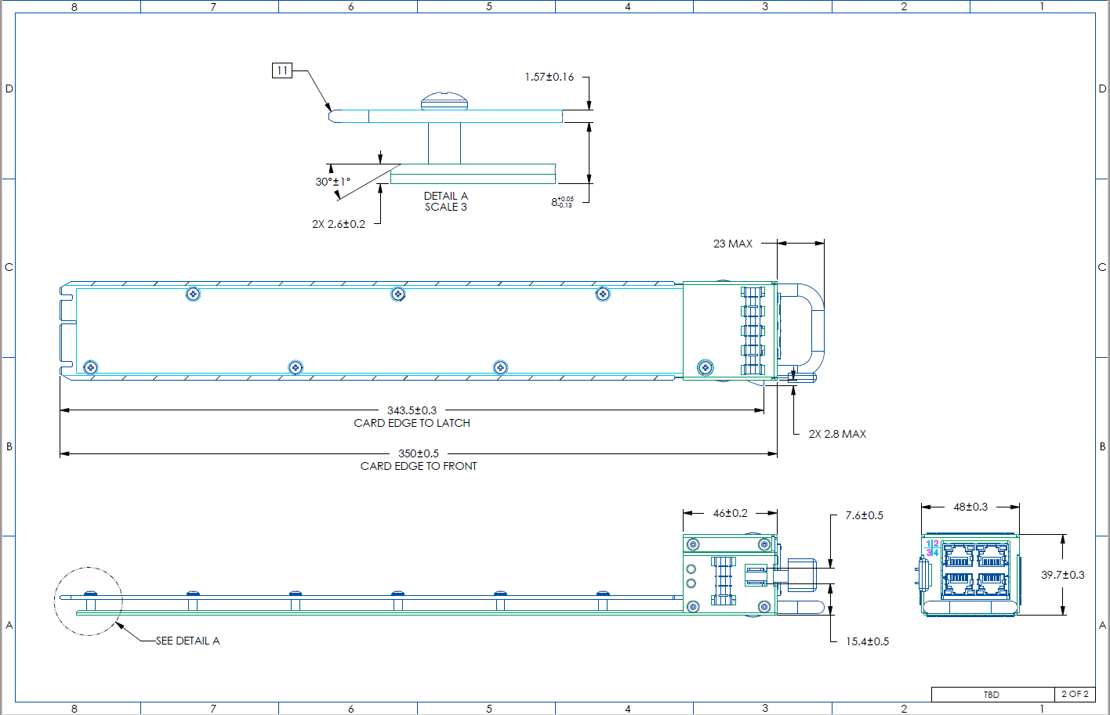

# **Compliance requirements**

## **Safety Standards**

Power/Battery Shelf Management Controller (PMI) shall be tested together in the OCP power shelf and shall comply with all safety requirements specified in OCP Open Rack V3 Power shelf and Battery shelf

Any component or signal that controls charging and discharging battery shall be evaluated under single fault condition per UL62368-1 Annex M

## **EMC Requirements**

Power/Battery Shelf Management Controller (PMI) shall be tested together in the OCP power shelf and shall comply with all EMC requirements specified in OCP Open Rack V3 Power shelf document.

## **Environmental Compliance**

Manufacturer of PMI shall provide full material disclosure, and technical documentations to demonstrate compliance to environmental compliance requirements such as ROHS, REACH, WEEE etc, depending on the end user’s goals and business need.

## **​Documentation**

Power/Battery Shelf Management Controller (PMI) shall be covered under all documents specified in OCP Open Rack V3 Power shelf document.

# **Serviceability**

## **Required collateral**

Shall include (at minimum) schematics, CAD, block diagrams, I2C diagram, Switch and jumper settings, service/repair/assembly/disassembly instructions (if applicable), LED definitions.

## **FRU information**

FRU labels will include part number and serial number. FRU SEEPROM shall be per IPMI spec.

## **PCB information**

PCBs shall have silkscreen markings for jumpers, LEDs, and FRUs.

* 1. **Port Symbols**

The Management Ethernet connectors shall have the text “MGMT” printed on or the metal stamped “MGMT” near the dedicated network port and include appropriate pictogram, and Sideband RJ45 shall have the text “SB” printed on or the metal stamped “SB” near the dedicated network port and include appropriate pictogram.

* 1. **Cold Aisle Repairs**

PMI shall be serviced from the Cold Aisle

* 1. **Programmable updates**

Non-disruptive (no reboot required) update capability is required for all programmable devices. Utilities shall be provided by the Design Partner with the capability to up and down-rev each article of firmware in the equipment.

* 1. **Additional Service Requirements**

Additional Service requirements may be added based on Safety and Data Center requirements. Contact specification owner for latest requirements.

# **Thermal**

* 1. **Environmental (operational)**
* Cold aisle (inlet) temperature: -5°C to 45°C
* Relative humidity: 10% to 90%, non-condensing
* Altitude: up to 3050m (10,000ft)
* Acoustic noise: If active cooling is required, target sound pressure should not exceed 85dBA when fan modules are running at full speed and operating within the defined environmental envelope.
  1. **Thermal requirements**
* Operational
  + Thermal margin: Reserving adequate margins on components is critical. These margins should be defined with respect to de-rated values, as appropriate. Following are the requirements.
    - Component thermal margin of ≥7% or ≥5°C up to 30°C inlet/ambient and 3050m (10,000ft) above sea-level. Target whichever value is larger.
    - Component thermal margin of ≥4% or ≥3°C at greater than 30°C inlet/ambient and up to 3050m (10,000ft) above sea-level. Target whichever value is larger.
    - Margin to de-rated temperatures should account for associated differences in reading and measurement location. Impact to reliability should also be considered when determining required margin.
* Thermal kit
  + Sensor accuracy: For discrete and critical sensors (such as ambient temperature), an accuracy of ≤±2°C is required (≤±1°C is preferred). If a component does not have an integrated temperature sensor, and uses a proxy, need to target an accuracy ≤±5°C (≤±2°C is preferred). If this component is temperature sensitive, thermal margin requirements defined above should account for sensor inaccuracy.
  + System fan (if required): Should be sized to support operation across environmental and loading envelopes, with an adequate operating range (speed) to achieve requirements outlined in this document. The fan should also have adequate overhead to accommodate back-pressure resulting from shelf design, rack-level accessories and data center operation. In general, head room to overcome a back-pressure of ≥ 0.3 inches of water is highly recommended. This does not take in to account impedance created at the front of the shelf to entrain airflow in the PMI (if required). In addition, to ensure thermally-efficient operation, airflow greater than 5CFM should be avoided.
  + Surface temperature: To make the PMI safe for handling in-operation, accessible surfaces should not exceed a temperature of 70°C.

# **Vibration and Shock (non-packaged)**

The PMI/PMC Module shall meet vibration and shock test per EN 60068-2-6 and 60068-2-27respectively and is to be performed at system shelf level (i.e. power shelf installed with PSUs and PMI/PMC module).

Please refer to section 7.1 of ORV3 Power shelf specifications.

# **Package Vibration, Drop and Compression**

PMI/PMC Modules units in their package shall meet the following requirements:

|  |  |  |
| --- | --- | --- |
| Package Vibration | 1.146 Grms, 2-200-2 Hz, all three axes, Random Vibe | ISTA 3E 06-06 |
| Package Drop | 8-inch drop | ISTA 3E 06-06 |
| Package Compression | Maximum compression loading on a bulk pack | ASTM D 642-94 |